Accepted Version

ID JNN-25-003 (R2)

May 22, 2025

**Investigation of Magnetized Slip Flow of Hybrid Nanofluid Past Nonlinearly Radiative Sheet with Newtonian Heating: Physics Informed Neural Network Simulation**

M.M.H. Imran1, S. Mojumdar1, M.J. Uddin1*

1Department of Mathematics, American International University-Bangladesh, Dhaka, Bangladesh

*Email:*[***imran.math@aiub.edu***](mailto:imran.math@aiub.edu)***,*** [***skmojumdar@aiub.edu***](mailto:skmojumdar@aiub.edu)***,***  [***drjashim@aiub.edu***](mailto:drjashim@aiub.edu)***, jashim_74@yahoo.com.***

**Abstract**

Magnetohydrodynamic slip flows of nanofluids have many industrial applications such as cooling of electronic devices, polymer extrusion, and biomedical engineering applications. Stimulated by these applications, the present paper investigates theoretically and numerically the external boundary layer flow of an electroconductive hybrid-nanofluid on a 2-D nonlinear-radiative sheet with Newtonian heating and Naiver slip effect at the sheet boundary. The physico-mathematical model is framed using a system of partial differential equations along with physically realistic boundary conditions (slip and Newtonian heating) which are then transformed into a set of similarity differential equations using coordinate transformations developed by group theory. The transformed equations are then solved by a sophisticated technique, physics informed neural network (PINN). PINNs are the class of deep learning algorithm designed to solve differential equations. PINNs offer a data driven approach that’s considered governing physical laws directly into the learning process. We have applied limited memory [Broyden–Fletcher–Goldfarb–Shanno algorithm](https://en.wikipedia.org/wiki/Broyden%E2%80%93Fletcher%E2%80%93Goldfarb%E2%80%93Shanno_algorithm) (L-BFGS) optimizer for learning process that updates the initial weights and biases. We also have applied to an L-BFGS optimizer for learning processes that update the initial weights and biases requirements. The mean square error for each case is the order of . The training loss values for PINN are gradually decreasing or somewhere fluctuating with the epoch number. To justify the precision of the method, present results are compared with the existing results and an excellent correlation is found. It is found that with the increase of $Nr$, Nusselt number increases by $0.3125\%$ if we add $Al_{2}O_{3}$ and $Cu$ nanoparticle with $H_{2}O$. Possible applications of the findings are magnetically guided drug delivery, electronic cooling systems, microscale bioreactors, and nanoparticle transport in medical diagnostics.

**Keywords: Newtonian heating, Slip flow, Nonlinear radiation, PINN, MHD flow; Hybrid nanofluid**

1. **Introduction**

Fluid flows and heat transfer of nanofluids are the study of motion that investigates the complicated behavior of fluid motion, and heat transfer dealing with a wide spectrum of physical events in nature and in our daily lives. Magnetohydrodynamic (MHD) flow is the study of the behavior of electrically conducting fluids in the presence of magnetic fields, has emerged as a potential sub-branch of fluid mechanics. Magnetic lubrication is a crucial component of contemporary MHD technology. Improved temperature management and flow control are two benefits of lubricants with MHD characteristics. They are smart lubricants in this sense since they can be made to function in a variety of ways, particularly under harsh circumstances. Applications for magnetic lubricants are numerous, namely include gears [1], sliding surfaces [2], and rolling bearings [3]. The boundary layer region, a thin layer at the vicinity of surface, is of great importance to researchers worldwide because of its real-world uses in chemical engineering, industry, biomedicine, aircraft, microbiology, food processing, Descemet’s membrane detachment [4] and many other fields. Stagnation flow is defined as zero velocity at a certain place, typically around blunt bodies or obstructions. Such applications include heat exchangers with fluid flow that stagnates at the surface, flow patterns, aircraft wings, and so forth. The first person to investigate stagnation flow towards the diminishing sheet was Wang [5]. In the presence of the MHD effect, Anuar et al. [6] investigated the same problem with a varied surface temperature. Ali et al. [7] used an induced magnetic field to study stagnation flow. Hayat et al. [8] employed the homotopy analysis method (HAM) approach to solve the nonlinear equations and discovered that it performed exceptionally well when compared to other numerical techniques. Daniel et al. [9] applied electromagnetic nanofluid flow with the impact of thermal radiation and chemical reactions. They found that thermal radiation greatly impacts on the thermal process.

Nanofluids are a form of engineered fluid that consists of a base fluid, typically a liquid such as water or oil, and microscopic particles suspended in it. These nanoscale particles, which are often metallic or ceramic, range in size from 1 to 100 nm. Since nanofluids have many uses in many technological and industrial processes and this topic has served a lot of contributions, especially in the twenty-first century. One major obstacle is the development of nanofluids in heat transfer is their stability, which is a requirement for studying them [10–13]. In order to create a nonhomogenous technical combination for the convective manufacture of nanomaterials with heat transport restrictions, Buongiorno [14] proposed a new model. The concept of using nanoparticles to improve the thermal performance of carrier fluids was first reported by Choi *et al.* [15]. In such a vertical sheet, Ramzan *et al.* [16] discovered the nanofluid flow with autocatalytic chemical processes under sliding circumstances and heat radiation. Turkyilmazoglu [17] tested the linear stability of a single-phase nanofluid and investigates its effects on material and fluid spectacle. Katta and Jayavel [18] investigated the increase in heat transmission in the radiative peristaltic motion of a nanofluid when stretched by a strong magnetic field. Daniel *et al.* [19] investigated the effects of radiative heat transfer and ohmic heating on the unsteady electromagnetohydrodynamics of a nanofluid flow past a vertically stretching sheet with the presence of double stratification, heat generation, and chemical reaction. Khan *et al.* [20] investigated the modified idea of homogeneous-heterogeneous reactions in the flow of Casson material. The numerical analysis of the impact of nanofluid during the melting process was demonstrated by Li *et al.* [21]. Kannigah et al [22] applied power law on blood flow model stenosis artery which is applicable for the optimizing drug delivery system. However, slip condition is highly effective in the manufacturing process and has important applications in many sectors. Many researchers think that introducing velocity slip at the interface will boost heat transfer. Since the constant temperature assumption at the surface is ineffective in many physical settings, several researchers have recently focused on Newtonian heating rather than constant surface temperature. The procedure in which internal resistance is insignificant in comparison to surface resistance is known as Newtonian heating.

Previous research suggests Newtonian heating was one of the four temperature distribution patterns near walls firstly examined by Merkin [23]. The effects of heat transmission over a stretched sheet with Newtonian heating were examined by Salleh et al. [24]. In recent years, tremendous progress has been made in understanding heat transfer in nanofluid systems, in which tiny particles are suspended in base fluids to improve thermal properties. In this context, nonlinear thermal radiation, Newtonian heating, and the application of modern computational methods such as Physics-Informed Neural Networks (PINNs) have received a lot of interest.

For conventional analytical and numerical techniques, the intricacy of heat transfer models involving nonlinear radiation, Newtonian heating, and nanofluids poses serious difficulties. It is challenging to obtain closed-form solutions or even to solve the governing equations efficiently using traditional computing techniques like finite difference or finite element approaches due to their linked nature, which frequently involves nonlinear partial differential equations (PDEs). Recent studies have concentrated on utilizing developments in machine learning and artificial intelligence (AI), especially neural networks, to overcome these issues. Neural networks have demonstrated considerable potential in modelling complicated systems because they can learn detailed patterns from data. In the domain of heat transfer, neural networks have been used to approximate PDE solutions by learning from simulation or experimentation. This data-driven technique can considerably reduce the computational time necessary to solve large-scale systems, making it possible to address more complicated issues. However, a fully data-driven method frequently demands a big volume of data, which is not always available.

To address this restriction, Physics-Informed Neural Networks (PINNs) have emerged as a potential solution that incorporates the fundamental physical principles regulating a system into the neural network training procedure. Raissi et al. [25] proposed PINNs, which use a physical system's governing equations as constraints during neural network training, ensuring that the network's predictions follow known physical laws. In the context of heat transfer, this means that the neural network's loss function incorporates the differential equations that regulate temperature distribution, fluid flow, and radiative heat flux. Farooq et al. [26] analyzed thermal energy problem by combining ANN and particle swarm optimization algorithms.

Cuomo [27] explored scientific computation using PINN in his article, including ODEs, steady-state equations, nonlinear PDEs, Navier-Stokes equations, and so on, where PINN has been shown to be a potential alternative to standard numerical solutions of these issues. This neural network model is currently widely used in a variety of applications, including face recognition, pattern recognition, classification, bioinformatics, and many others [28–33]. Milano and Koumoutsakos [34] developed a neural network technique for recovering near-wall fields in turbulent flow through numerical simulations. The results were compared to POD predictions, demonstrating greater reconstruction and prediction abilities for near-wall velocity fields. This technique has benefits and drawbacks for turbulence modelling and control. Further research has been conducted to investigate NN's applications in turbulent flow regimes [35-37]. NNs have also been utilized to solve classification problems such as identifying different regimes in multiphase flow (bubbly, slug, plug, etc.) [38] or detecting the many forms of vortexes that develop behind an airfoil [39].

The PINN technique solves ODEs and PDEs by transforming them into optimization problems. Dissanayake [40] and Lagaris [41] were the first to attempt to find a closed solution using the ANN approach. Lagaris’ defines the trail solution as two parts: the first satisfies the boundary and beginning conditions, and the second is a neural solution with unknown parameters weight and bias. The researchers at Brown University overcame this trial solution and solved PDEs without letting the trial solution. Ricci [42] used the PINN method to solve the Navier-Stokes equations. Blasius equation with the trial solution was solved by Mutuk [43], for that trial solution was adopted but this was not unique. He got the relative error are order of , so that it gave poor solution in some boundary node. On the other hand, Bararnia [44] was the first to solve three benchmark boundary layer issues with PINN. For this, the governing PDEs are turned into a system of ODEs, which are then translated into an optimization problem. He used the ADAM optimizer to minimize errors and update parameters.

Motivated by past work on boundary layer equations and PINN, we use the PINN technique to solve the boundary layer equations in this study. We investigated a forced convective, two-dimensional steady magnetohydrodynamics flow with a radiation parameter imbedded in porous media. The fundamental concept is to use the PINN methodology to explore solutions and compare them to traditional numerical algorithms. The PINN training procedure relies heavily on optimization. There are five popular optimizers: Gradient method, Gradient method with momentum, ADAM, Levenberg-Marquardt (LM), and L-BFGS. The LM technique has a greater convergence rate but requires more memory, followed by the L-BFGS optimizer, which has a higher convergence rate but requires less memory [42,44]. For this, L-BFGS optimizer (which convergence rate is fast compared to the ADAM optimizer) is employed to optimize the loss function and update the initial guessed weight and biased (More detailed will be discussed in below). Prior to this, governing PDEs are converted into ODEs using magnitude transformation. The advantage of PINNs is their ability to solve PDEs without requiring significant amounts of data. Instead, they use the problem's known physics to direct the training process, making them ideal for modelling complex heat transfer systems where experimental data collection is difficult. PINNs have been effectively applied to a variety of problems, including fluid dynamics, electromagnetism, and structural mechanics. They have been used in heat transfer applications to simulate temperature distributions in complex geometries and with a variety of boundary conditions. The incorporation of PINNs in the study of heat transfer with hybrid nanofluids provides a powerful tool for solving the nonlinear equations caused by the existence of nonlinear radiation and Newtonian heating. Researchers can create more accurate predictive models for thermal system design and optimization by combining nanofluids' improved thermal characteristics with the flexibility and accuracy of PINNs. The collected results are analyzed based on error analysis, and the effect of various control parameters is graphically shown. Hopefully, this study will be useful in the study of boundary layer equations using the PINN methodology.

This study presents a novel and comprehensive illustration of forced convective flow of hybrid nanofluid over a solid sheet with nonlinear radiation, Newtonian heating and velocity slip boundary— a combination not previously addressed in the literature. The inclusion of Newtonian heating and velocity slip and nonlinear radiation and solved using a **group-theory-based similarity transformation**, and Physics Informed Neural Network further distinguishes this work. To the best of the authors' knowledge, this is the first attempt to analyze the interplay of these complex mechanisms in a unified framework, offering critical insights for designing advanced thermal and biological transport systems in engineering and biomedical applications.

1. **Physical Model**

We consider the stagnation-point slip flows of viscous incompressible hybrid fluid flow past a nonlinear-radiative solid sheet (Fig. 1) with Newtonian heating boundary. A transverse variable magnetic field of strength,  [50] is applied perpendicular below the surface (*L* is the characteristic length). Fluid properties are assumed to be constant. The free stream velocity is  and free stream temperature . Newtonian heating and velocity slip boundary conditions are considered. Using the order of magnitude analysis, the governing equations in dimensional form can be expressed as [50,51].

 (1)

 (2)

. (3)

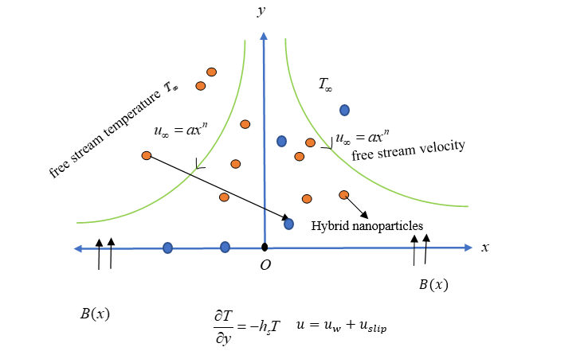

Figure 1: Non-linear radiative shrinking/stretching sheet.

The *x*-coordinate is taken along the leading edge of the sheet, and the *y*-coordinate is orthogonal to the sheet.

Using non-linear radiation [52-54]

 .

Now (3) becomes,

 (4)

The associated wall and free-stream boundary conditions are (Salleh et al. [24])

 (5)

In Eq. [2], : represent the convection acceleration in the direction, : free stream velocity gradient, :diffusion term representing the effect of viscosity,: the electric magnetic damping effects due to applied magnetic field $B.$ In Eq. [3], : represents convective transport of temperature in the direction, : represents thermal diffusion due to heat conduction, : represents the heat transfer due to the radiation effect.

Also, the thermophysical properties of nanoparticles and base fluid are given in Table 1 [57,60].

Table 1: Thermo physical properties of nanoparticles and base fluid [57,60]

|  |  |  |  |  |
| --- | --- | --- | --- | --- |
| Physical Properties | $$C_{p}(JKg^{-1}K^{-1})$$ | $$ρ(Kgm^{-3})$$ | $$k(Wm^{-1}K^{-1})$$ | $$σ(Sm^{-1})$$ |
| $$H_{2}O$$ | $$4179$$ | $$997.1$$ | $$0.613$$ | $$0.05$$ |
| $$Cu$$ | $$385$$ | $$8933$$ | $$401$$ | $$5.96×{10}^{7}$$ |
| $$Al_{2}O_{3}$$ | $$765$$ | $$3970$$ | $$40$$ | $$3.69×{10}^{7}$$ |

And the nanoparticle properties: [57,61]



(6)

**3. Solution Methodology**

* 1. **Similarity Solutions**

To reduce the governing equations Eqs. [1-2,4] and boundary conditions Eq. [5] the following coordinated transformations developed by group method (Seshadri and Na [58], Vajravelu et al. [59])

 (7)

Here *η* is dimensionless transverse coordinate,  is a dimensionless stream function and is dimensionless temperature. After, introducing Eqn. (7) into Eqs. [(1), (2), (4)], the continuity equation is automatically satisfied and the following system of dimensionless nonlinear ordinary differential equations, i.e. the reduced momentum and thermal boundary layer equations emerges:

 (8)

 (9)

The normalized boundary conditions (5) take the form:

 (10)

The dimensionless parameters arise Eqs. (8)- (10) are as follows

 (magnetic number), $Pr=\frac{μ_{f}c_{p}}{k_{f}}$ (Prandtl number), (velocity slip), (stretching (λ>0) or shrinking (λ<0)),  (stationary sheet). (conjugate parameter for Newtonian heating), , (radiation), (temperature ratio).

* 1. **Physical Quantities**

The definitions of friction factor and temperature gradient are given below [59]

 (11)

where  represent the shear stress and surface heat flux on the sheet respectively. These quantities are defined as follows:

 (12)

Using Eqs. (7) and (11) in Eq. (11)



Here, is the local Reynolds number.

* 1. **Physics Informed Neural Network**

Many authors applied Artificial Neural Network (ANN) techniques to solve various transport problems. For example, the authors in references [45-49] used the Levenberg Marquardt (LM) artificial neural networks approach. In the Levenberg Marquardt artificial neural networks technique previous data sets are needed for training, testing and validation purposes. To generate previous data, we must use conventional numerical methods like shooting, finite difference and finite element. However, no prior data is needed to use p**hysics** informed neural network method, which is one of the advantages of the current method**.** Like Artificial Neural Network (ANN) technique PINN also consists of three layers namely input layer, hidden layer and output layer but PINN involves the physics of the problem. Previously ANN was used as a statistics toolbox which links between input data and output data without knowing the physics of the problem. Lagaris [41] was the first person who came up with the new idea of solving ODEs and PDEs using ANN. For that, a trial solution needed which satisfy the initial and boundary conditions as well as governing equations but set of this trial solution is cumbersome when dealing with complex initial and boundary conditions. On the other hand, the PINN method doesn’t need this type of trial solution, it converts the problems into optimization problems over the geometry of the problem including governing equations and boundary conditions.

To deal with the PINN, first, we converted our PDEs into ODEs depending on the η using similarity solutions. We divided the boundary domain into colocation points with the step size . We also considered the finite value for where the flow converges. These boundary modes, is our only input value (one input layer). Throughout this research, we consider 9 hidden layers with 30 neurons each. For each layer, we apply ‘tanh’ layer and lastly output layer has 2 features, . In figure (2), we illustrate the working procedure of PINN. (Hidden layers and neurons are minimized in this figure

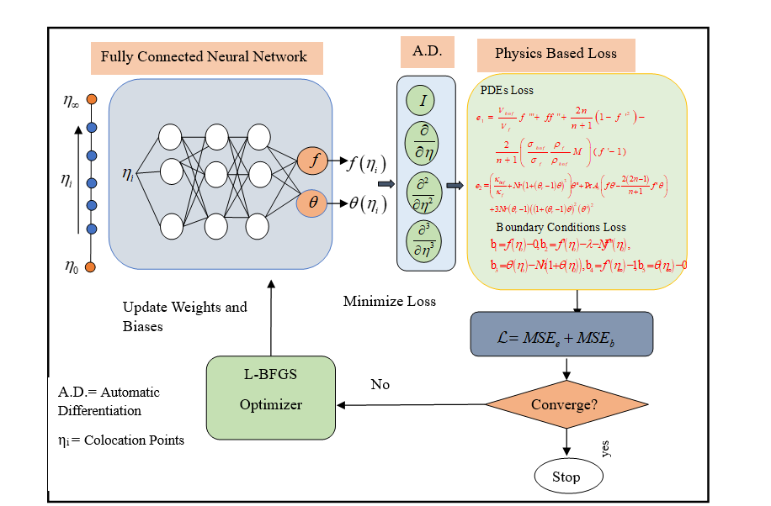

Figure 2: Schematic Diagram of Physics Informed Neural Network.

The function  consists of some learning parameters named weights (w) and biases (b) which must be trained to find the optimality solutions. The weights define the relevance of the signal delivered to the node or, in other words, how much each node contributes to the next subsequent node and all contributions to the output result of the representative node. Then, to account the contribution of all the nodes on the output node, the total of weighted inputs is computed, and lastly, a bias is applied to the obtained sum:

 (13)

($m$ = number of neurons, $k=1,…,n$, $n$ =number of hidden layers) and value added to next layer with the formula:

 (14)

The information of all neurons is carried to output layers and gives the output,.

These outputs are fitted through the automatic differentiation (A.D.) into the loss functions, the boundary conditions are also considering this loss function, which gives us total loss. Now our main work is to minimize the total loss function. Here, we used L-BFGS optimizer to minimize the error through the A.D. and update weights and biases.

Mean square error (MSE) is defined as  (15)

MSE value for PDE loss is defined as follows:

 (16)

MSE value for boundary loss is defined as follows:

 (17)

In table 2, PINN initial set up is shown with the number of neurons, hidden layers gradient tolerance and stop tolerance. [57].

Table 2: PINN set up with L-BFGS optimizer

|  |  |  |  |  |  |
| --- | --- | --- | --- | --- | --- |
| Properties | Neurons | Hidden Layers | Gradient Tolerance | Stop Tolerance | Max Iteration |
| Number | 30 | 9 |  |  | 2000 |

Other Properties:

1. Line Search Method: “Weak Wolf” Method to identify optimum learning rate. This technique provides a positive definite estimation of the inverse Hessian matrix.
2. Gradient threshold technique used to eliminate gradient values that surpass the gradient threshold: “L2 norm” (MSE), If the L2 norm of the gradient of a trainable guess parameter is bigger than Threshold value of Gradient, then this technique will adjust the gradient in a manner that the L2 norm or MSE matches Threshold value of the Gradient.
3. **Code Validation**

We have validated our PINN results for some fixed parameters that are shown in table 3.

For numerical computation we have used MATLAB ‘bvp4c’ solver. In this method we set the tolerance of order .

Table 3: Code validation with the published paper and numerical solutions while $(λ=2,N=0.5,n=1,ϕ_{1}=ϕ_{2}=0)$.

|  |  |  |  |  |  |
| --- | --- | --- | --- | --- | --- |
|  |  | | |  | |
| Published results | Present work | | Present work | |
| Parameter | Mahatha [53] | ‘BVP4C’ | PINN | ‘BVP4c’ | PINN |
| $$M=2$$ | -1.055995 | -1.055995 | -1.05600 | 0.62382 | 0.62379 |
| $$M=6$$ | -1.19783053 | -1.19783053 | -1.197828 | 0.6275447 | 0.62736 |

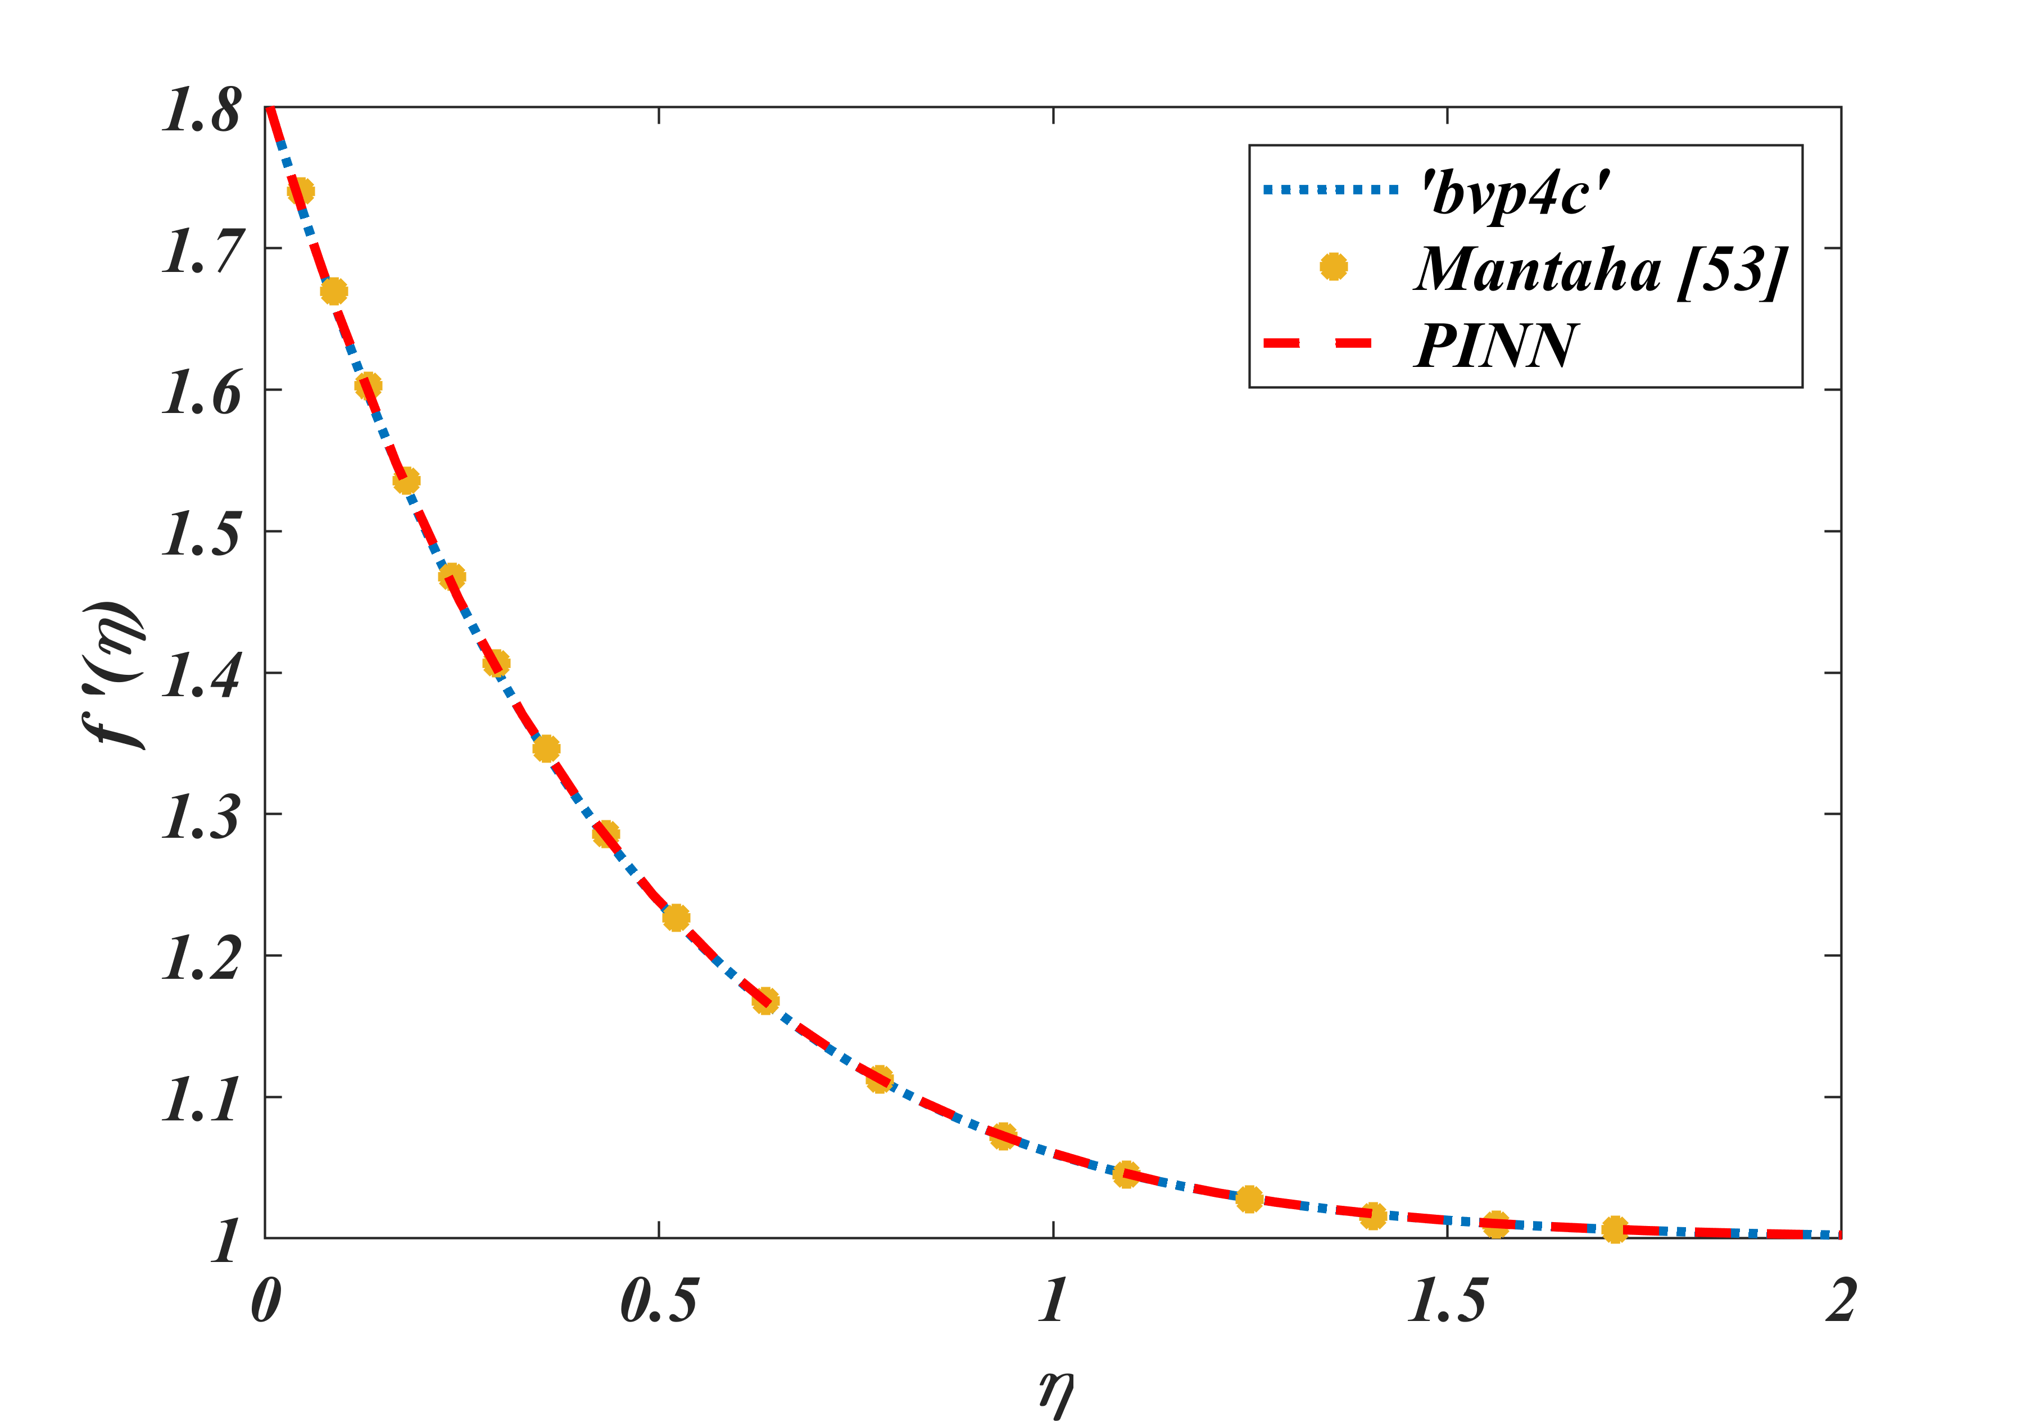

Figure 3: Validation with published paper and ‘bvp4c’

Table 3. and figure 3 ensure the validation of our PINN code. So, we can apply this code for further calculation. Both numerical and PINN code is written by authors of this article in the MATLAB software.

1. **Results and Discussion**

We have considered the PINN methodology for this research. For this present problem, we have considered ,,, and fixed Prandtl number. In figures 4-5, we have graphically illustrated the non-dimensional physical quantities friction $C_{fx}{\left(Re_{x}\right)}^{\frac{1}{2}}$ and Nusselt number $Nu_{x}{\left(Re_{x}\right)}^{-\frac{1}{2}}$. In figures 6-14, velocity and temperature profiles are drawn for different parameters with PINN training loss. PINNs gradient tolerance is set upand stop tolerance .

**4.1 Skin Friction and Nusselt Number:**

Table 4: Variation of the physical quantities with the controlling parameters $(ϕ_{1}=0.01,ϕ_{2}=0.01)$

|  |  |  |  |  |  |  |  |  |
| --- | --- | --- | --- | --- | --- | --- | --- | --- |
| $$n$$ | $$M$$ | $$N$$ | $$Nr$$ | $$θ_{r}$$ | $$λ$$ | $$Nh$$ | $$C_{fx}{\left(Re_{x}\right)}^{\frac{1}{2}}$$ | $$Nu_{x}Re_{x}^{-\frac{1}{2}}$$ |
| 0.5 | 1.0 | 0.1 | 2.0 | 0.5 | 0.2 | 0.5 | 0.98777 | 1.92348 |
| 1.0 | 1.0 | 0.1 | 2.0 | 0.5 | 0.2 | 0.5 | 1.17713 | 3.55977 |
| 2.0 | 1.0 | 0.1 | 2.0 | 0.5 | 0.2 | 0.5 | 1.48478 | 5.57394 |
| 2.0 | **0.0** | 0.1 | 2.0 | 0.5 | 0.2 | 0.5 | 1.33613 | 5.44516 |
| 2.0 | **1.0** | 0.1 | 2.0 | 0.5 | 0.2 | 0.5 | 1.48478 | 5.573917 |
| 2.0 | **2.0** | 0.1 | 2.0 | 0.5 | 0.2 | 0.5 | 1.61378 | 5.67945 |
| 2.0 | 1.0 | **0.0** | 2.0 | 0.5 | 0.2 | 0.5 | 1.69266 | 5.11872 |
| 2.0 | 1.0 | **0.15** | 2.0 | 0.5 | 0.2 | 0.5 | 1.39578 | 5.75376 |
| 2.0 | 1.0 | **0.2** | 2.0 | 0.5 | 0.2 | 0.5 | 1.31547 | 5.90938 |
| 2.0 | 1.0 | 0.1 | **0.0** | 0.5 | 0.2 | 0.5 | 1.48476 | 3.43924 |
| 2.0 | 1.0 | 0.1 | **1.0** | 0.5 | 0.2 | 0.5 | 1.48469 | 4.64516 |
| 2.0 | 1.0 | 0.1 | **3.0** | 0.5 | 0.2 | 0.5 | 1.48473 | 6.35246 |
| 2.0 | 1.0 | 0.1 | 2.0 | **0.2** | 0.2 | 0.5 | 1.48478 | 5.32142 |
| 2.0 | 1.0 | 0.1 | 2.0 | **0.8** | 0.2 | 0.5 | 1.48475 | 5.91576 |
| 2.0 | 1.0 | 0.1 | 2.0 | **1.0** | 0.2 | 0.5 | 1.48476 | 6.23575 |
| 2.0 | 1.0 | 0.1 | 2.0 | 0.5 | **-0.2** | 0.5 | 2.07933 | 4.08400 |
| 2.0 | 1.0 | 0.1 | 2.0 | 0.5 | **0.0** | 0.5 | 1.79642 | 4.86921 |
| 2.0 | 1.0 | 0.1 | 2.0 | 0.5 | **0.3** | 0.5 | 1.31908 | 5.90250 |
| 2.0 | 1.0 | 0.1 | 2.0 | 0.5 | 0.2 | **0.8** | 1.48477 | 5.20952 |
| 2.0 | 1.0 | 0.1 | 2.0 | 0.5 | 0.2 | **1.0** | 1.48478 | 4.98708 |

Table 4 shows non-dimensional physical quantities for varying the controlling parameters and fixing hybrid nanoparticle volume fraction. From this table we can observe that, when sheet is shrinking $(λ<0)$ friction factor is higher than others, but Nusselt number has largest impact factor for non-linear radiation $(Nr)$ and secondly for temperature ratio $(θ_{r})$. In table 5, we have compared friction factor and Nusselt number for mono nanofluid and hybrid nanofluid. When we add $Al_{2}O_{3}$ with monotonic mixture $Cu/H_{2}O$ heat transfer rate increases. The graphical representation of is given in figure 4 and 5. From figure 4(a) it is clearly visible that for shrinking sheet friction factor takes higher value also if we increase n from 0.5 to 1 friction factor boost up. But for stretching sheet Nusselt number become larger in figure 4(b) while increasing sheet stretching value with higher magnetic field boast up heat transfer rates. Same effects are observed in figure 5, for volume fraction with nonlinear parameter.

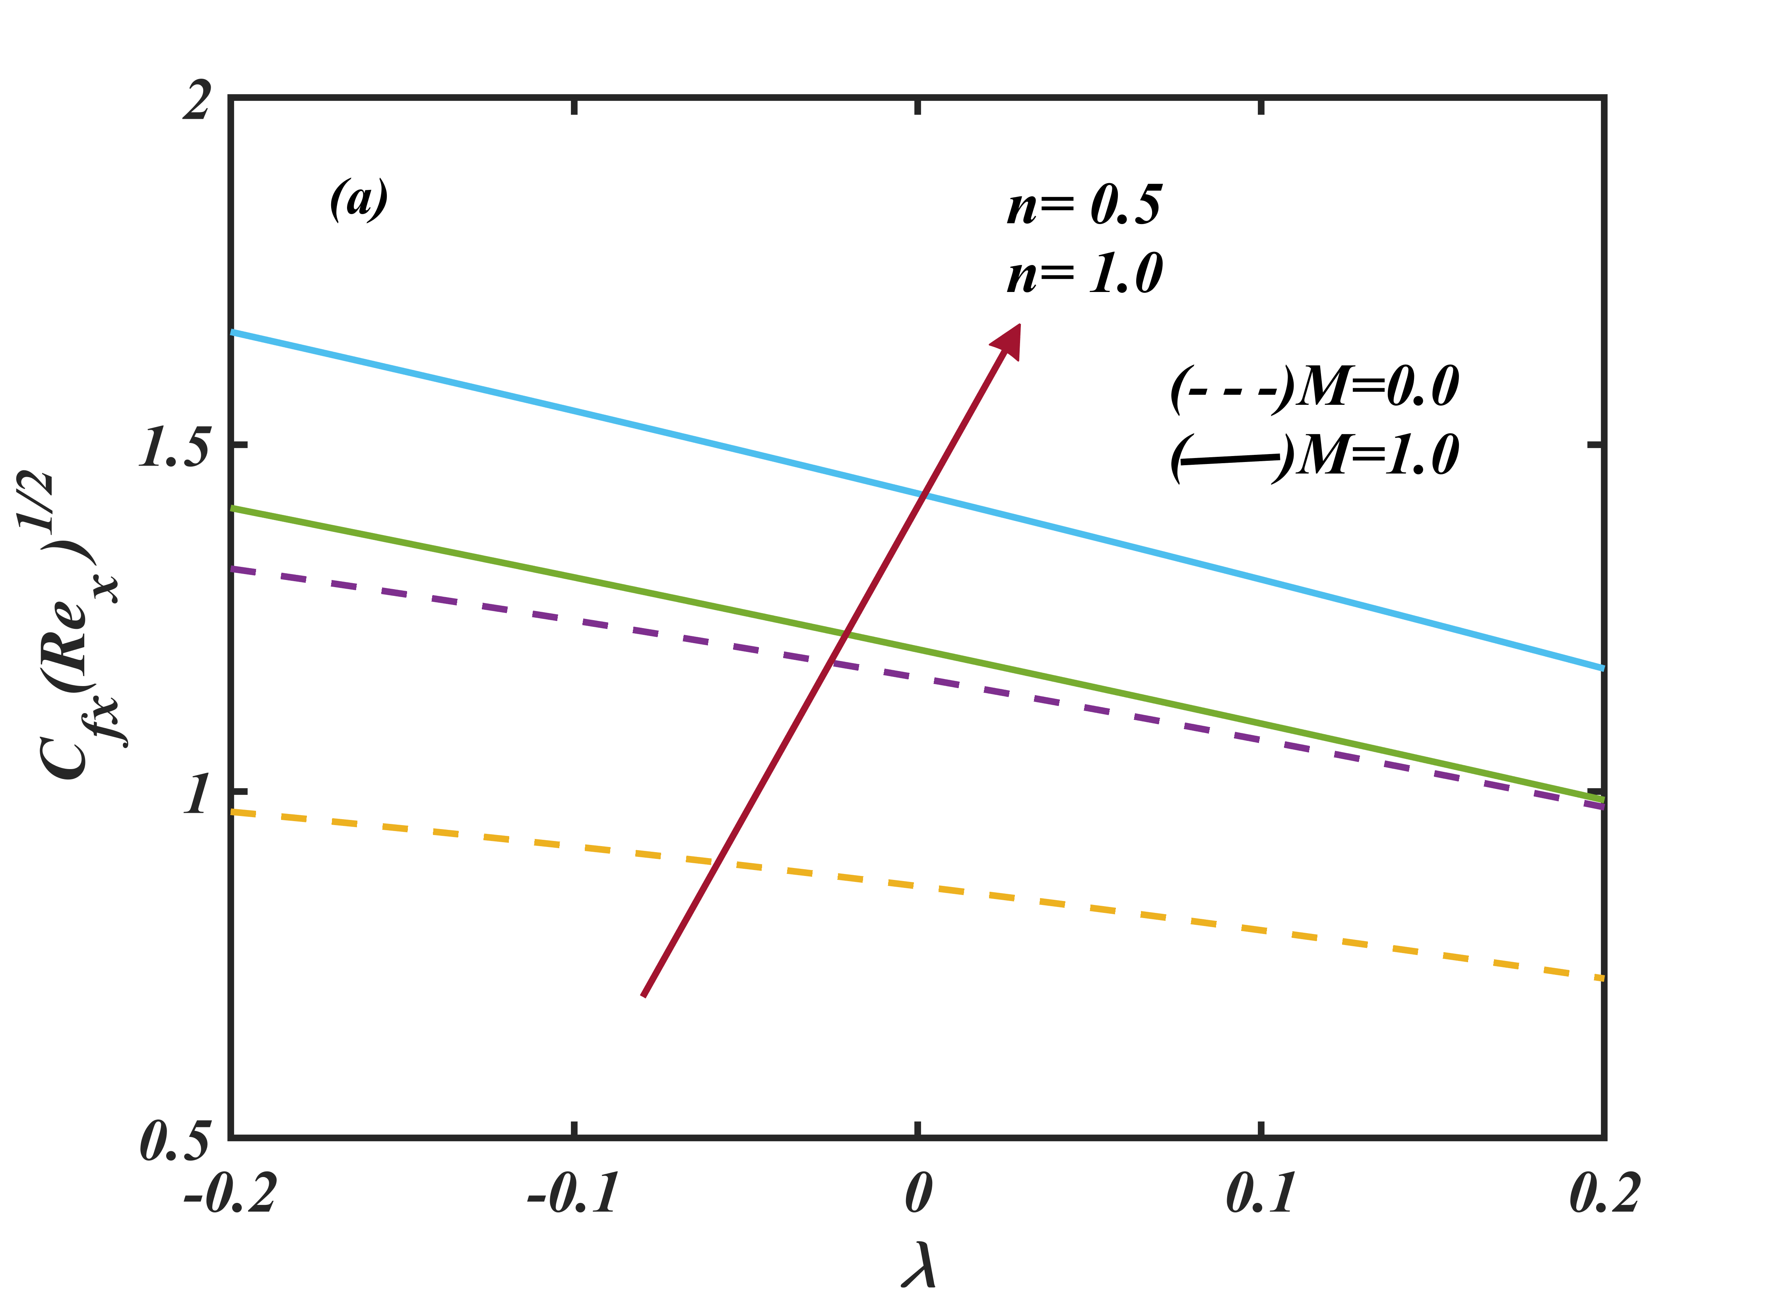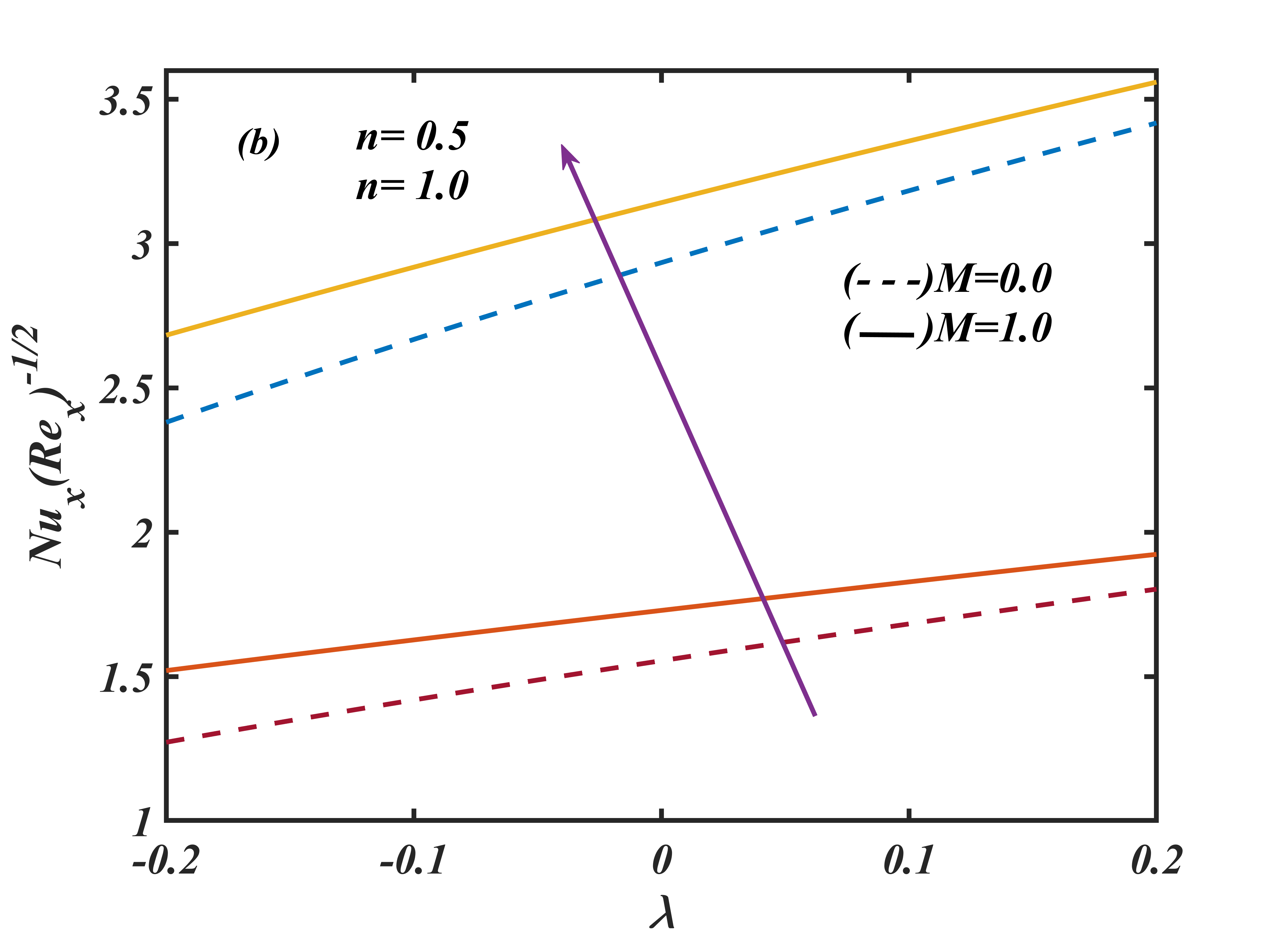

Figure 4: Non-dimensional $\left(a\right)C_{fx}{\left(Re_{x}\right)}^{\frac{1}{2}}$ and $\left(b\right)Nu_{x}{\left(Re_{x}\right)}^{-\frac{1}{2}}$ against $λ$ for .

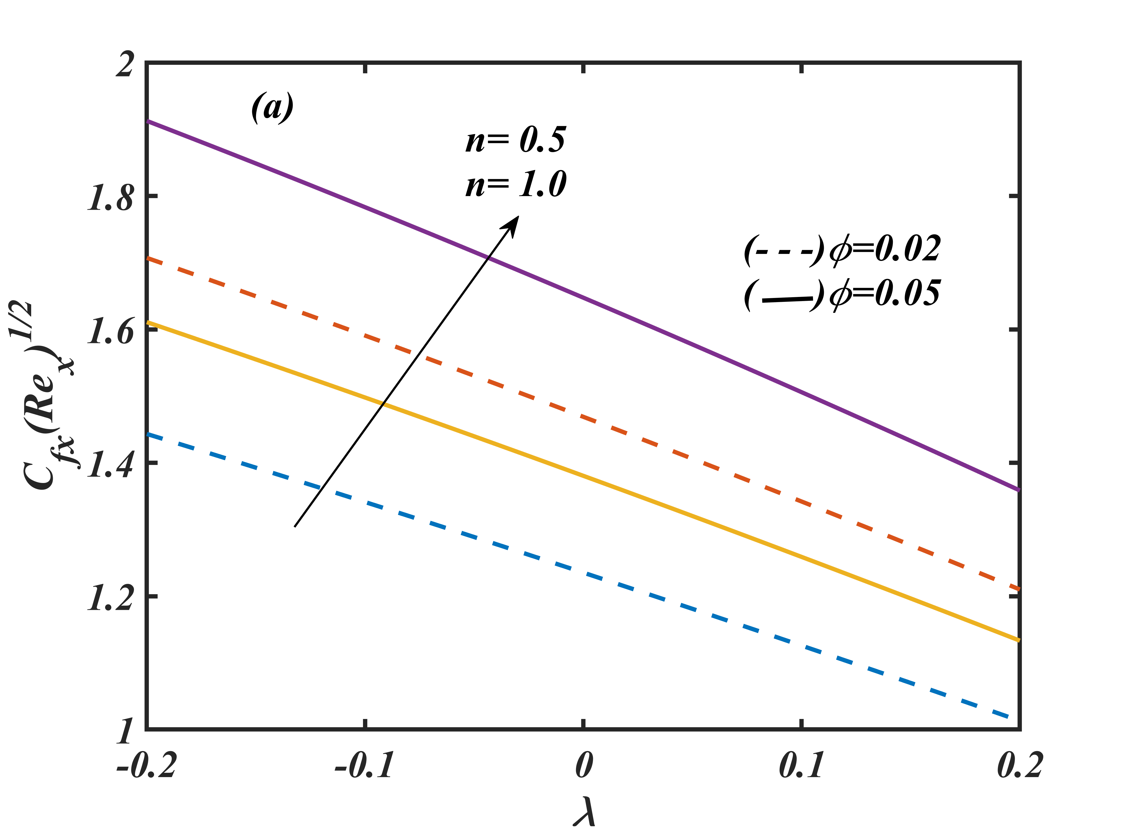

Figure 5: Non-dimensional $\left(a\right)C_{fx}{\left(Re_{x}\right)}^{\frac{1}{2}}$ and $\left(b\right)Nu_{x}{\left(Re_{x}\right)}^{-\frac{1}{2}}$ against $λ$ for $n,ϕ$.

Table 5: Comparison of friction and Nusselt number with the controlling parameters.

|  |  |  |  |  |  |  |  |  |  |  |
| --- | --- | --- | --- | --- | --- | --- | --- | --- | --- | --- |
| *Controlling Parameters* | | | | | | | $$(Cu\backslash H_{2}O)$$ Mono-nanofluid $$(ϕ_{1}=0.01)$$ | | $$(Cu-Al_{2}O_{3}\backslash H_{2}O)$$ Hybrid-nanofluid $$(ϕ_{1}=ϕ_{2}=0.01)$$ | |
| $$n$$ | $$M$$ | $$N$$ | $$Nr$$ | $$θ_{r}$$ | $$λ$$ | $$Nh$$ | $$C_{fx}{\left(Re_{x}\right)}^{\frac{1}{2}}$$ | $$Nu_{x}Re_{x}^{-\frac{1}{2}}$$ | $$C_{fx}{\left(Re_{x}\right)}^{\frac{1}{2}}$$ | $$Nu_{x}Re_{x}^{-\frac{1}{2}}$$ |
| 0.5 | 1.0 | 0.1 | 2.0 | 0.5 | 0.2 | 0.5 | 0.96317 | 1.91452 | 0.98777 | 1.92348 |
| 1.0 | 1.0 | 0.1 | 2.0 | 0.5 | 0.2 | 0.5 | 1.14806 | 3.54326 | 1.17713 | 3.55977 |
| 2.0 | **1.0** | 0.1 | 2.0 | 0.5 | 0.2 | 0.5 | 1.44838 | 5.54856 | 1.48478 | 5.573917 |
| 2.0 | **2.0** | 0.1 | 2.0 | 0.5 | 0.2 | 0.5 | 1.57390 | 5.65346 | 1.61378 | 5.67945 |
| 2.0 | 1.0 | **0.15** | 2.0 | 0.5 | 0.2 | 0.5 | 1.36154 | 5.72817 | 1.39578 | 5.75376 |
| 2.0 | 1.0 | **0.2** | 2.0 | 0.5 | 0.2 | 0.5 | 1.28318 | 5.88363 | 1.31547 | 5.90938 |
| 2.0 | 1.0 | 0.1 | **1.0** | 0.5 | 0.2 | 0.5 | 1.44838 | 4.61141 | 1.48469 | 4.64516 |
| 2.0 | 1.0 | 0.1 | **3.0** | 0.5 | 0.2 | 0.5 | 1.44838 | 6.33267 | 1.48473 | 6.35246 |
| 2.0 | 1.0 | 0.1 | 2.0 | **0.8** | 0.2 | 0.5 | 1.44838 | 5.88989 | 1.48475 | 5.91576 |
| 2.0 | 1.0 | 0.1 | 2.0 | **1.0** | 0.2 | 0.5 | 1.44838 | 6.20923 | 1.48476 | 6.23575 |
| 2.0 | 1.0 | 0.1 | 2.0 | 0.5 | **-0.2** | 0.5 | 2.02825 | 4.06035 | 2.07933 | 4.08400 |
| 2.0 | 1.0 | 0.1 | 2.0 | 0.5 | **0.3** | 0.5 | 1.28676 | 5.87666 | 1.31908 | 5.90250 |
| 2.0 | 1.0 | 0.1 | 2.0 | 0.5 | 0.2 | **0.8** | 1.44838 | 5.18578 | 1.48477 | 5.20952 |
| 2.0 | 1.0 | 0.1 | 2.0 | 0.5 | 0.2 | **1.0** | 1.44838 | 4.96475 | 1.48478 | 4.98708 |

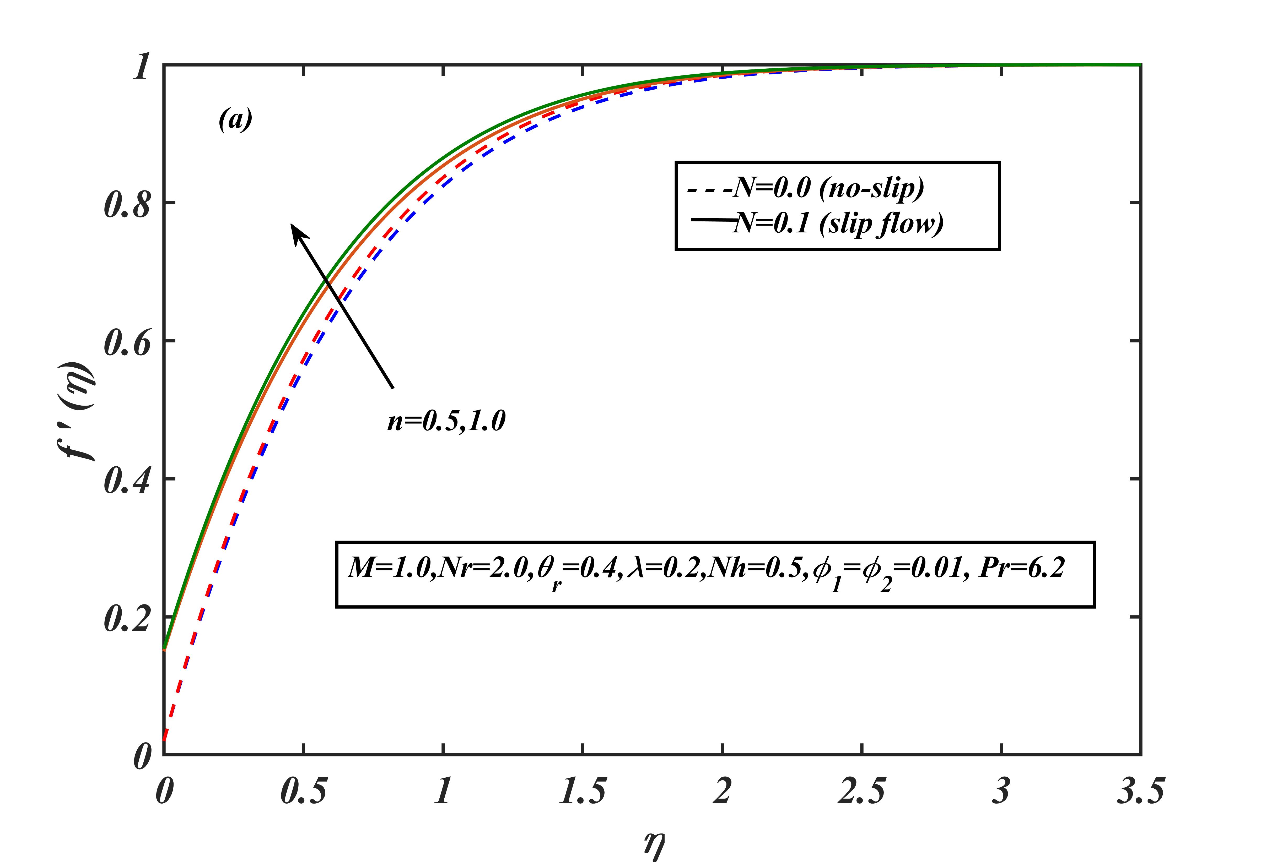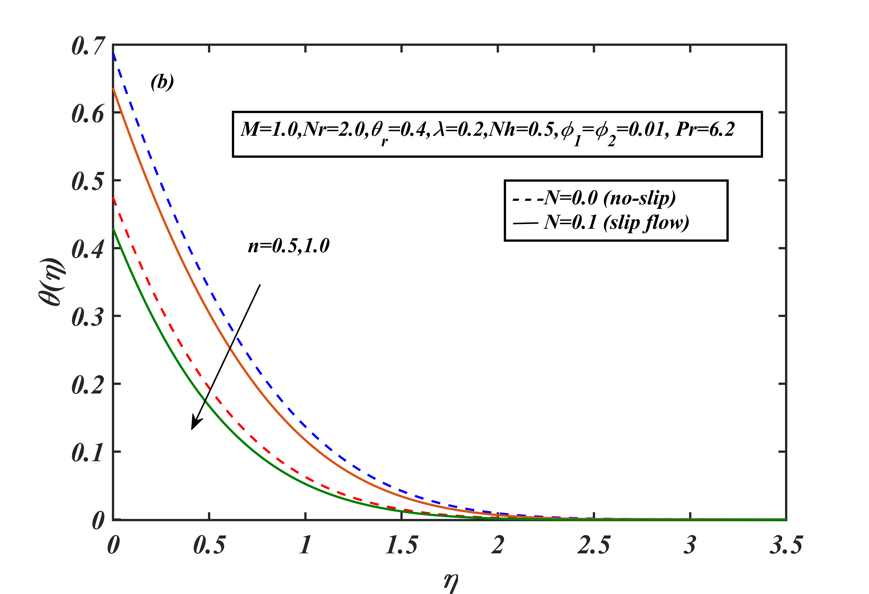

Figure 6: Effect of $n$ on (a) velocity profiles and (b) temperature profiles via $N$.

In Fig. 6, we consider the effect of $n$ on velocity and thermal profile. A larger $n$ represents a more rapidly stretching sheet from the leading-edge increases. This increasing sheet enhances the momentum of fluid therefore velocity increases and $N=0.1$ accelerates the near boundary fluid. On the other hand, the temperature profile is decreasing as an increase in $n$. Because stronger velocity increases thermal convection as a result thinner thermal layer decreases temperature profile. PINN estimated loss is plotted with the epoch number. The final loss for each case is: $1.25E-05,7.07E-06,5.00E-06 and 1.75E-05.$

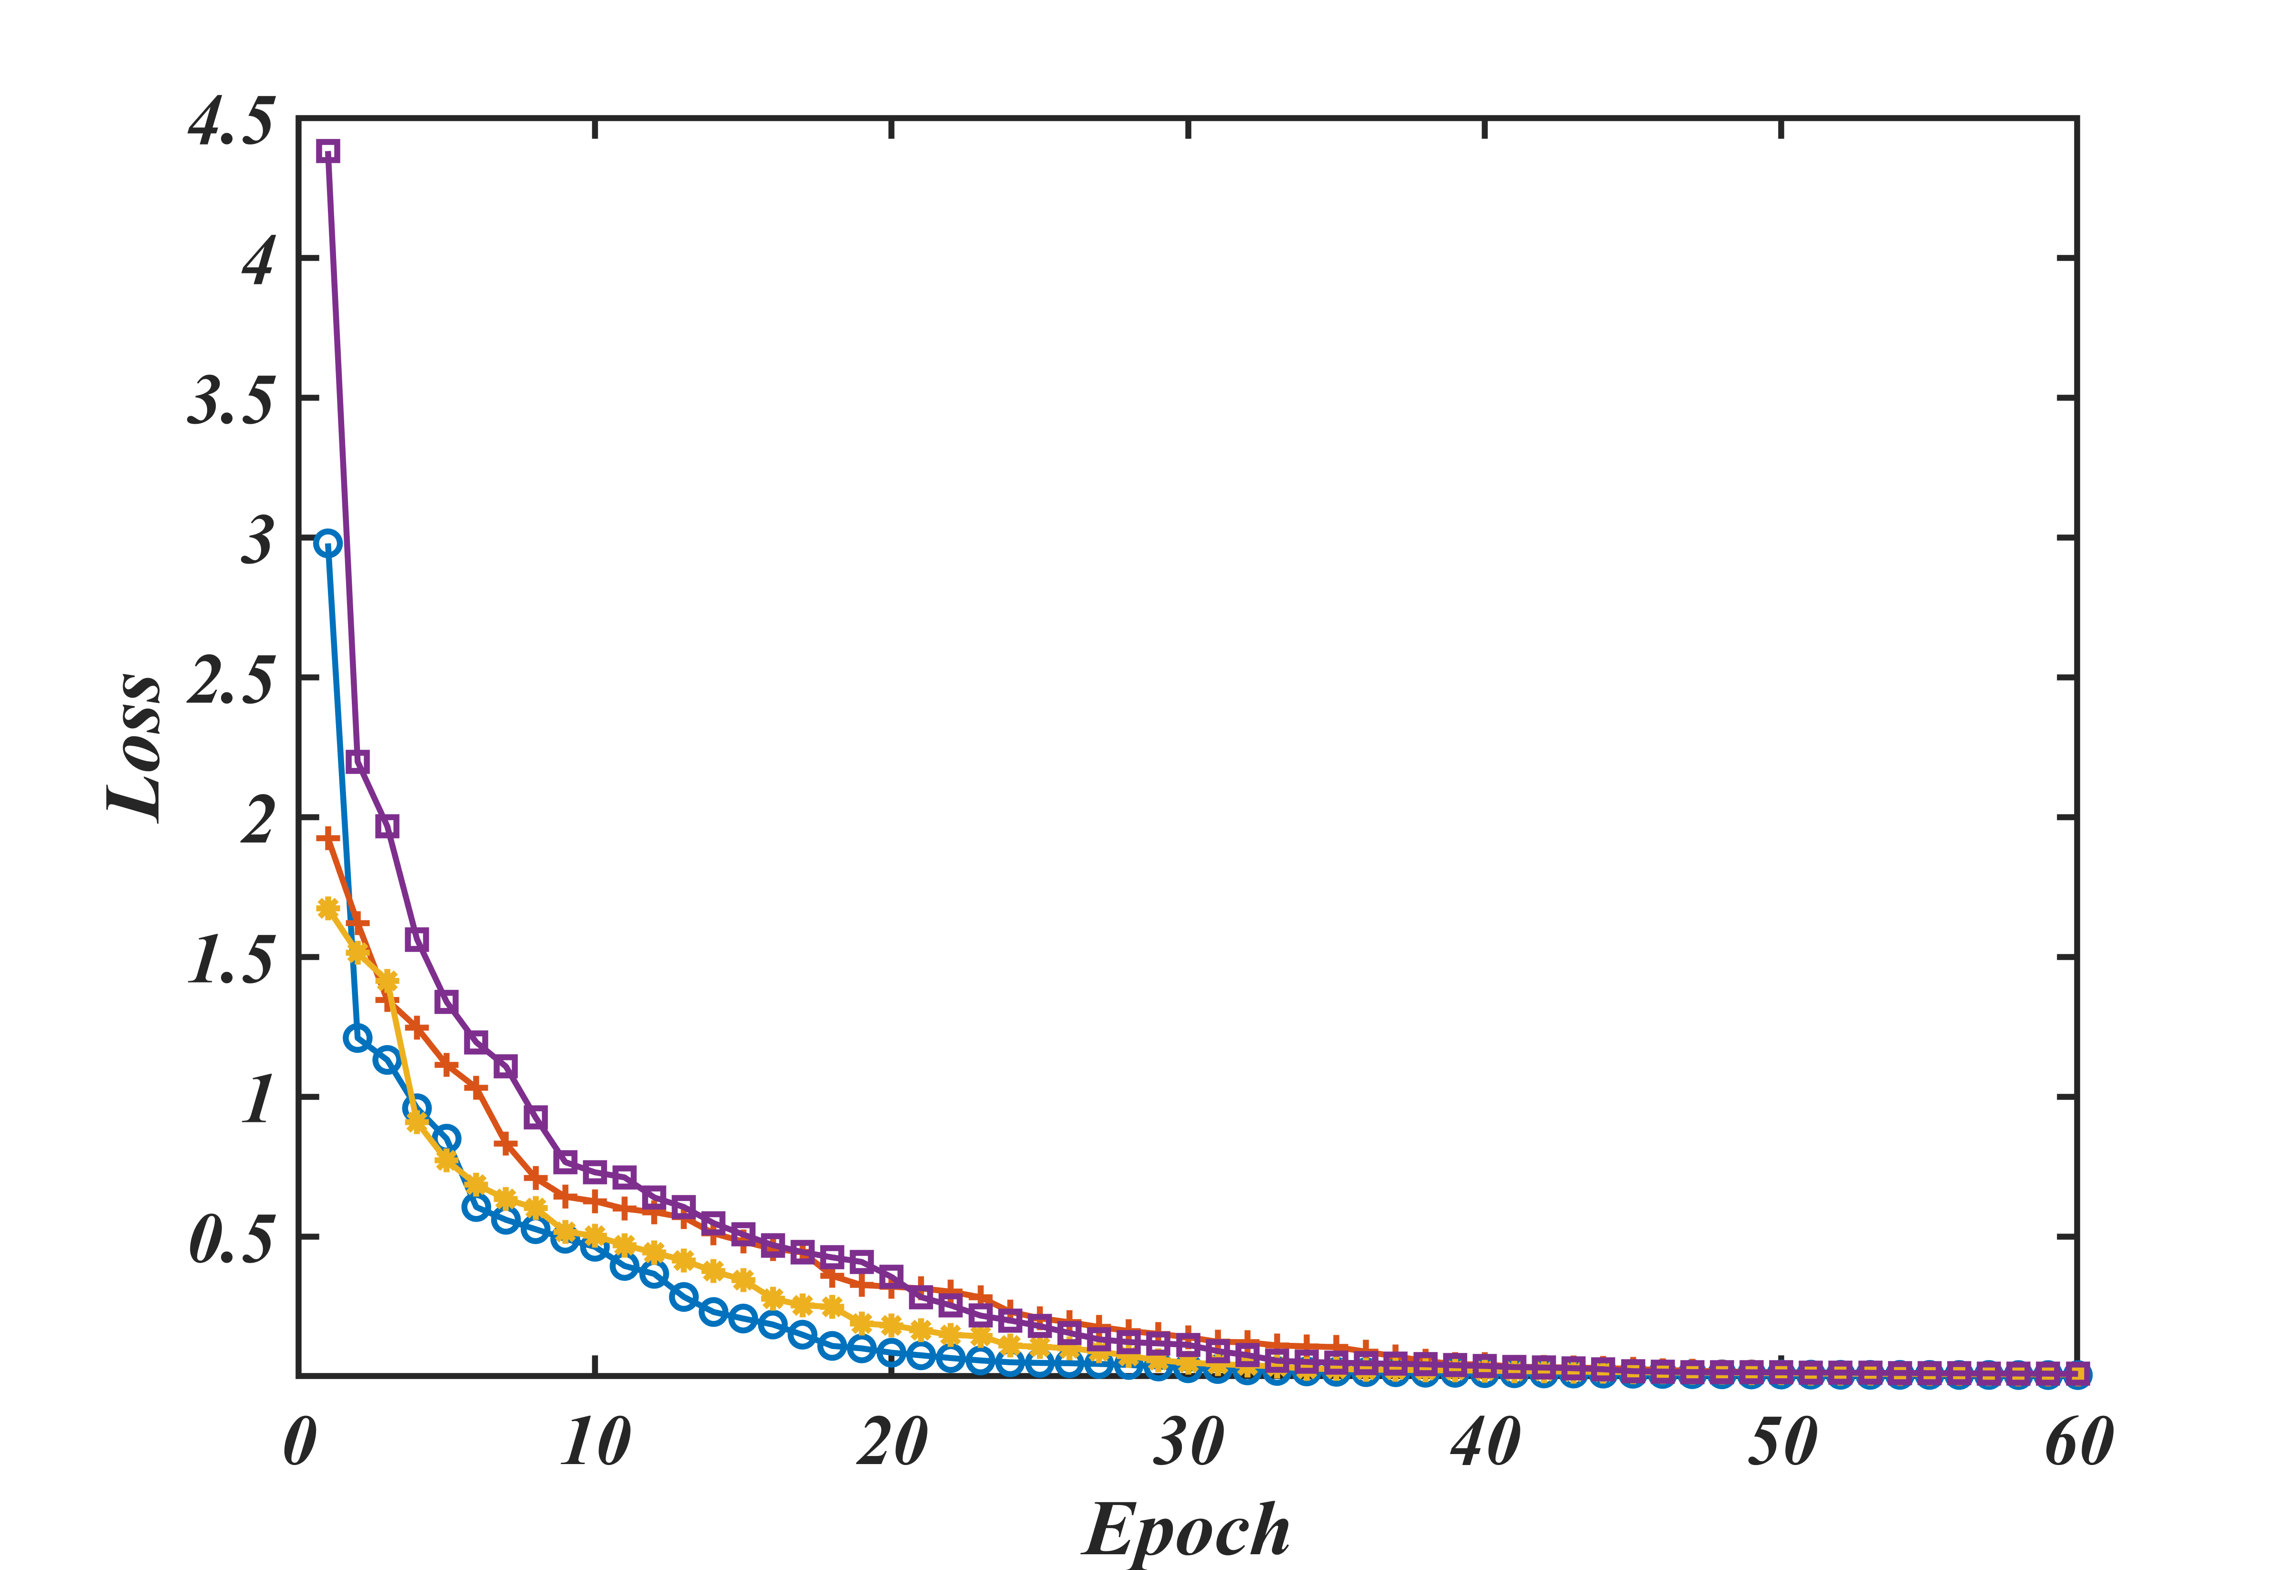

Figure 7: PINN training loss with the iteration.

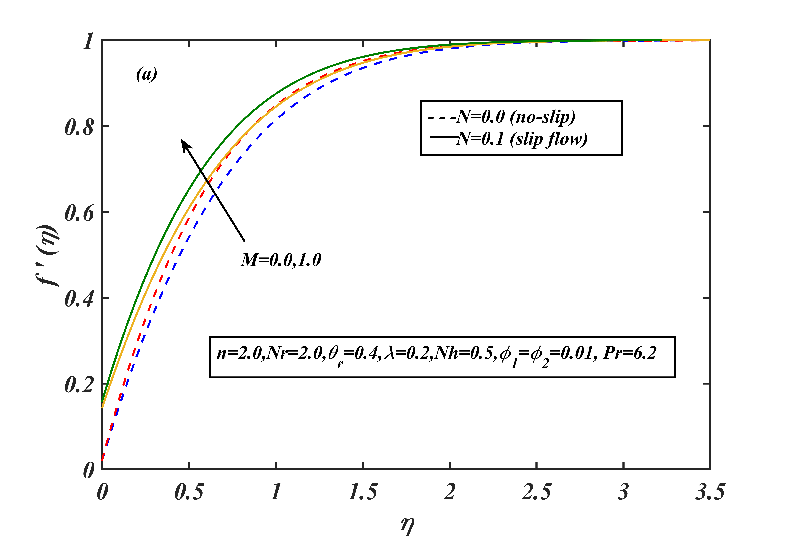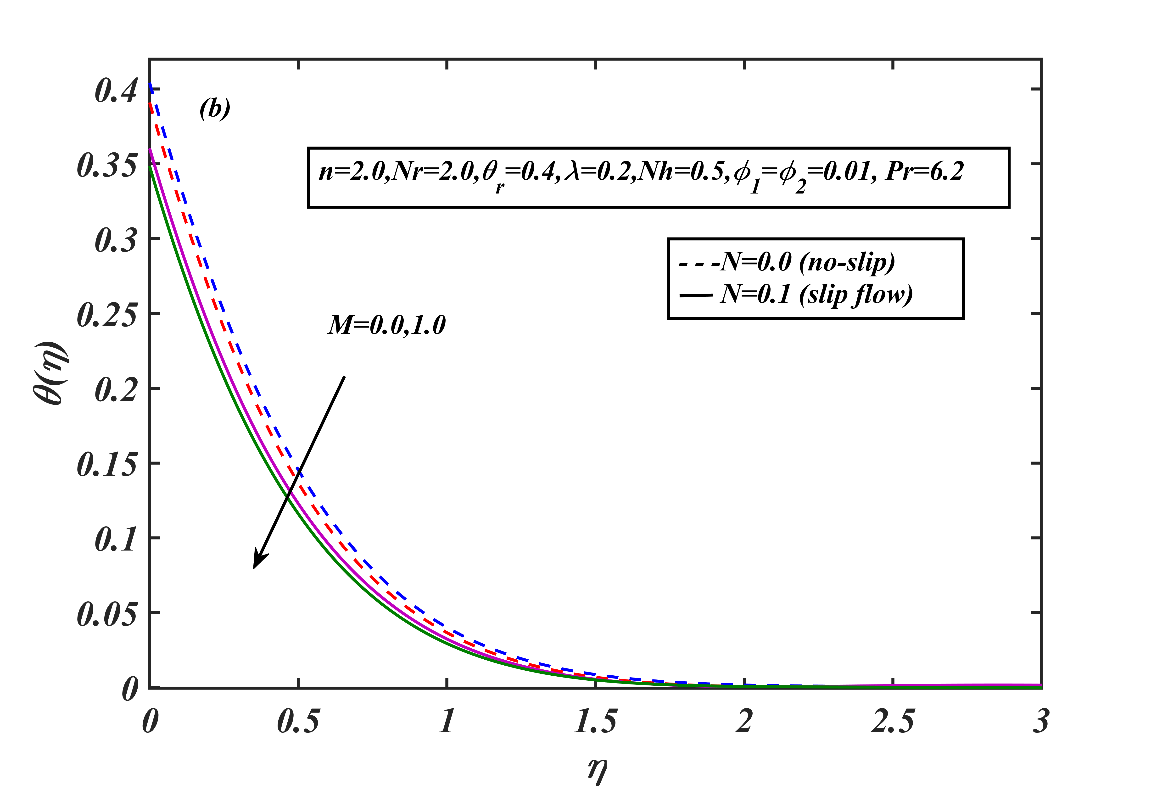

Figure 8: Effect of $M$ on (a) velocity profiles and (b) temperature profiles via $N$.

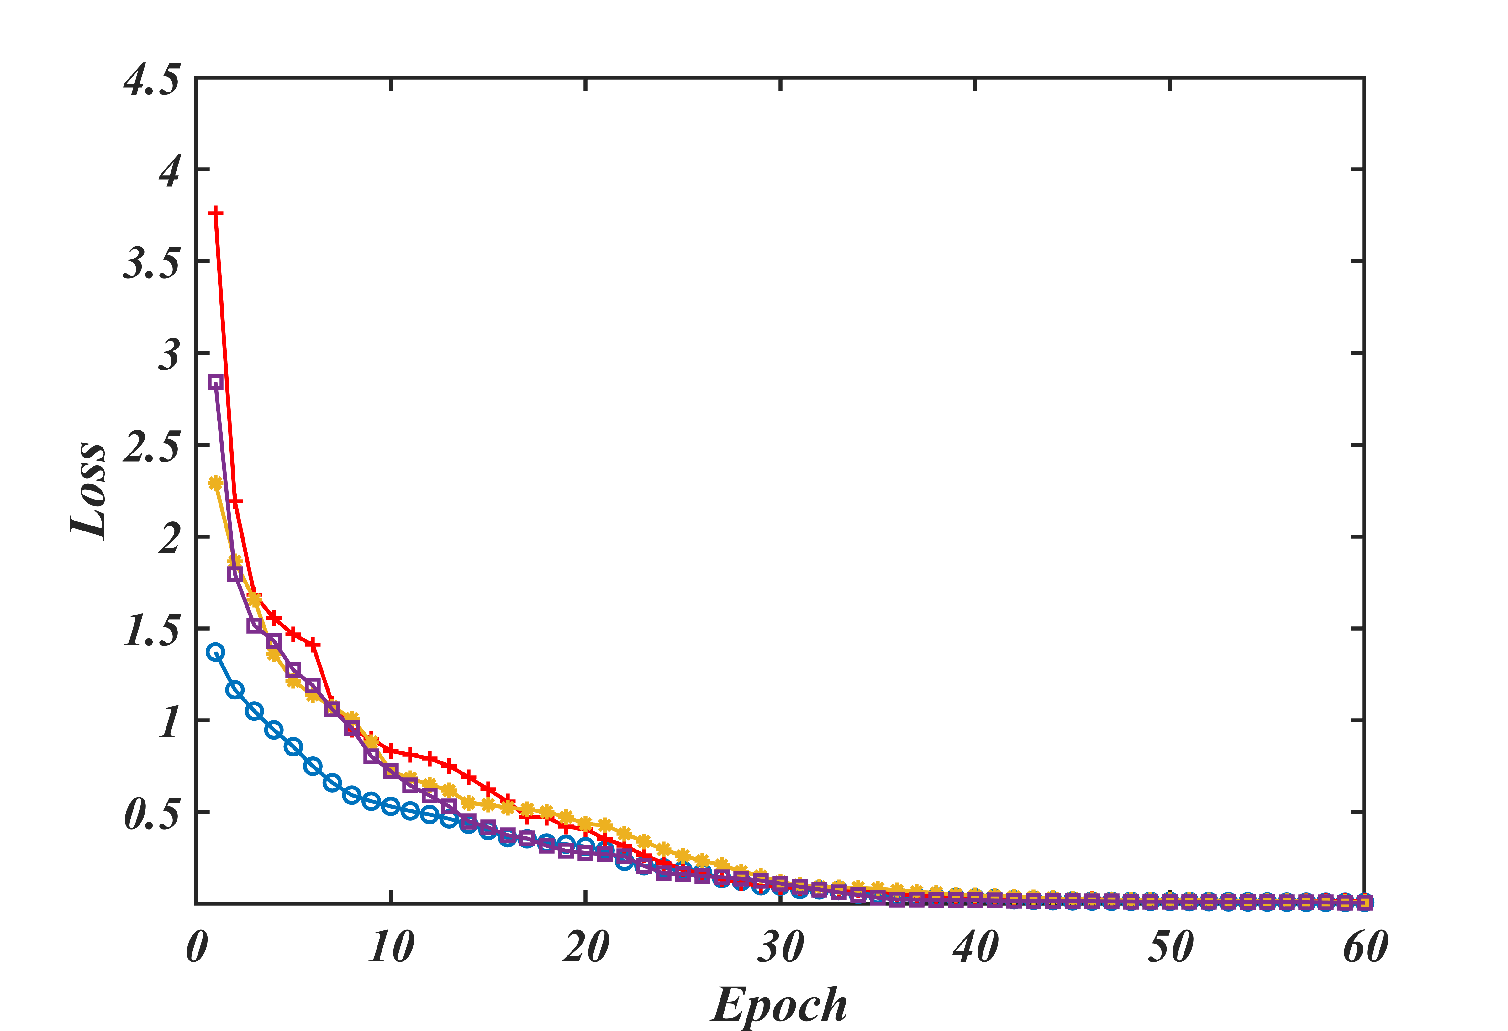

Figure 9: PINN training loss with the iteration.

In Fig. 8(a), we consider the impact of M on velocity profiles with slip and no slip, which shows that M has a positive impact on velocity profile. With no-slip flow $(N=0)$, when M increase from 0 to 1, velocity profiles increase, in the presence of magnetic term fluid experience extra resistance force called Lorentz force acts opposite to flow, this opposes force try to slow down the flow velocity as a result velocity profiles become more curved near the boundary surface. But we consider slip flow, $(N=1)$ fluid gets extra momentum initially due to this slip parameter. In Fig 8(b), we consider the effect M on $θ(η)$, thermal boundary layer decreases when we apply magnetic field on the flow profile, MHD effect creates resistive force near in the flow leading decreasing velocity, thus convective heat transfer decreases as a result temperature profiles decrease.

In Fig. 9, PINN loss function values plotted with epoch number, here we consider 4 cases slip flow with the absence and presence of MHD and no-slip flow with the absent and present of MHD. In all cases loss function $(L)$ are gradually decreasing with the epoch number. Maximum iteration chosen for each case 2000, at every iteration using line search method “weak wolf” algorithm that find optimum learning rate and Hessian matrix to minimize initially chosen weights and biases. The final loss for each case is: $8.4671E-06,1.0682E-05,1.1236E-05 and 1.6589E-05$.

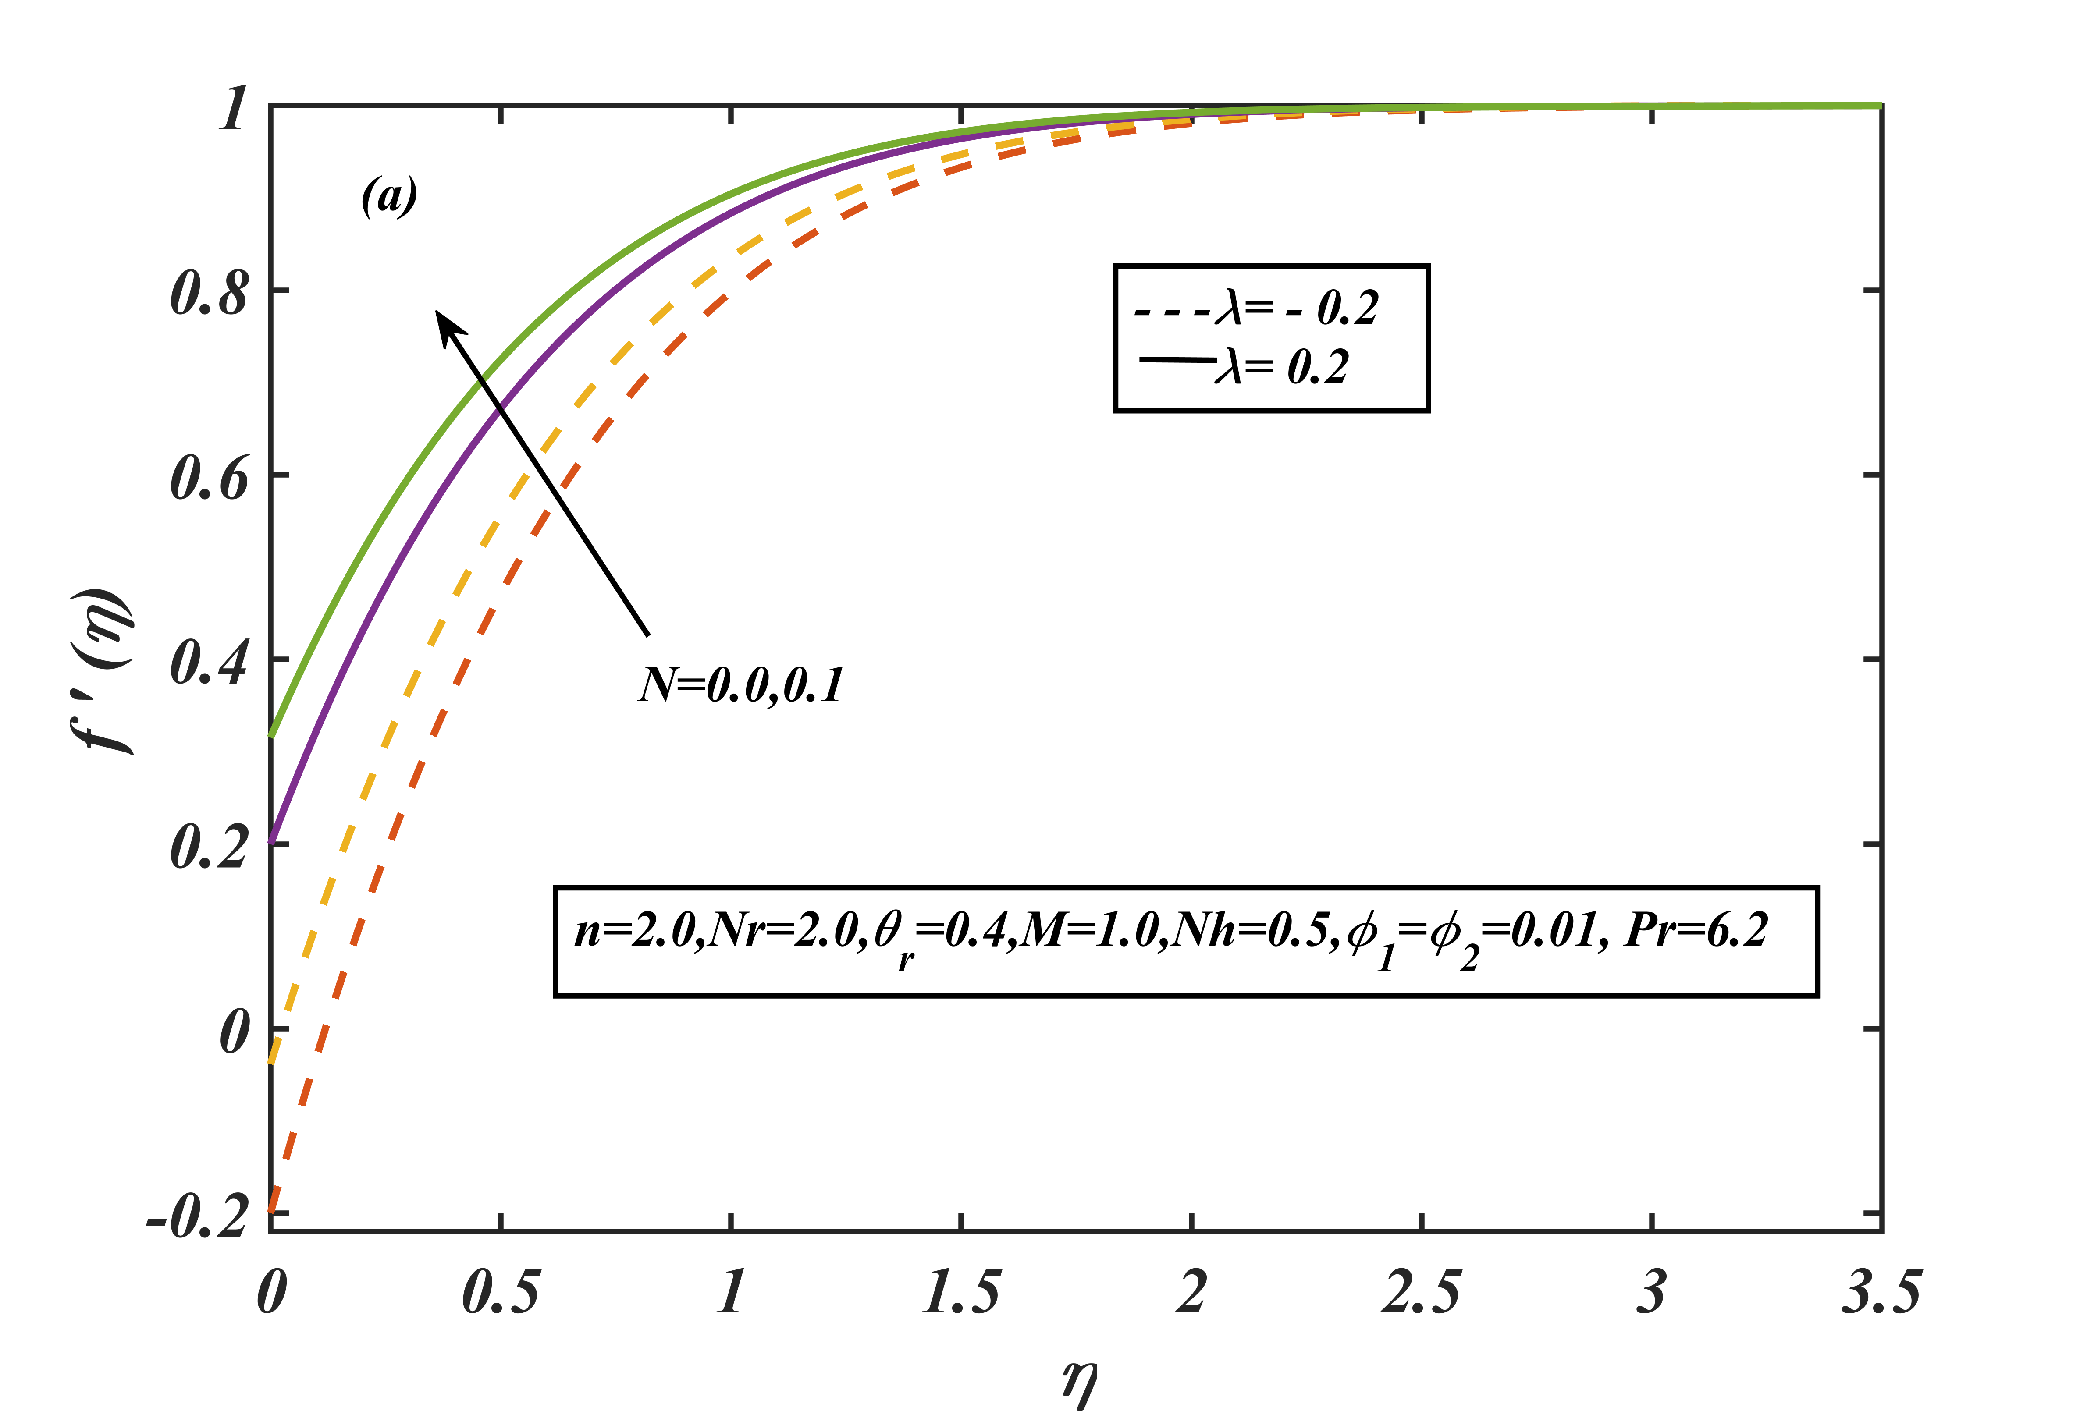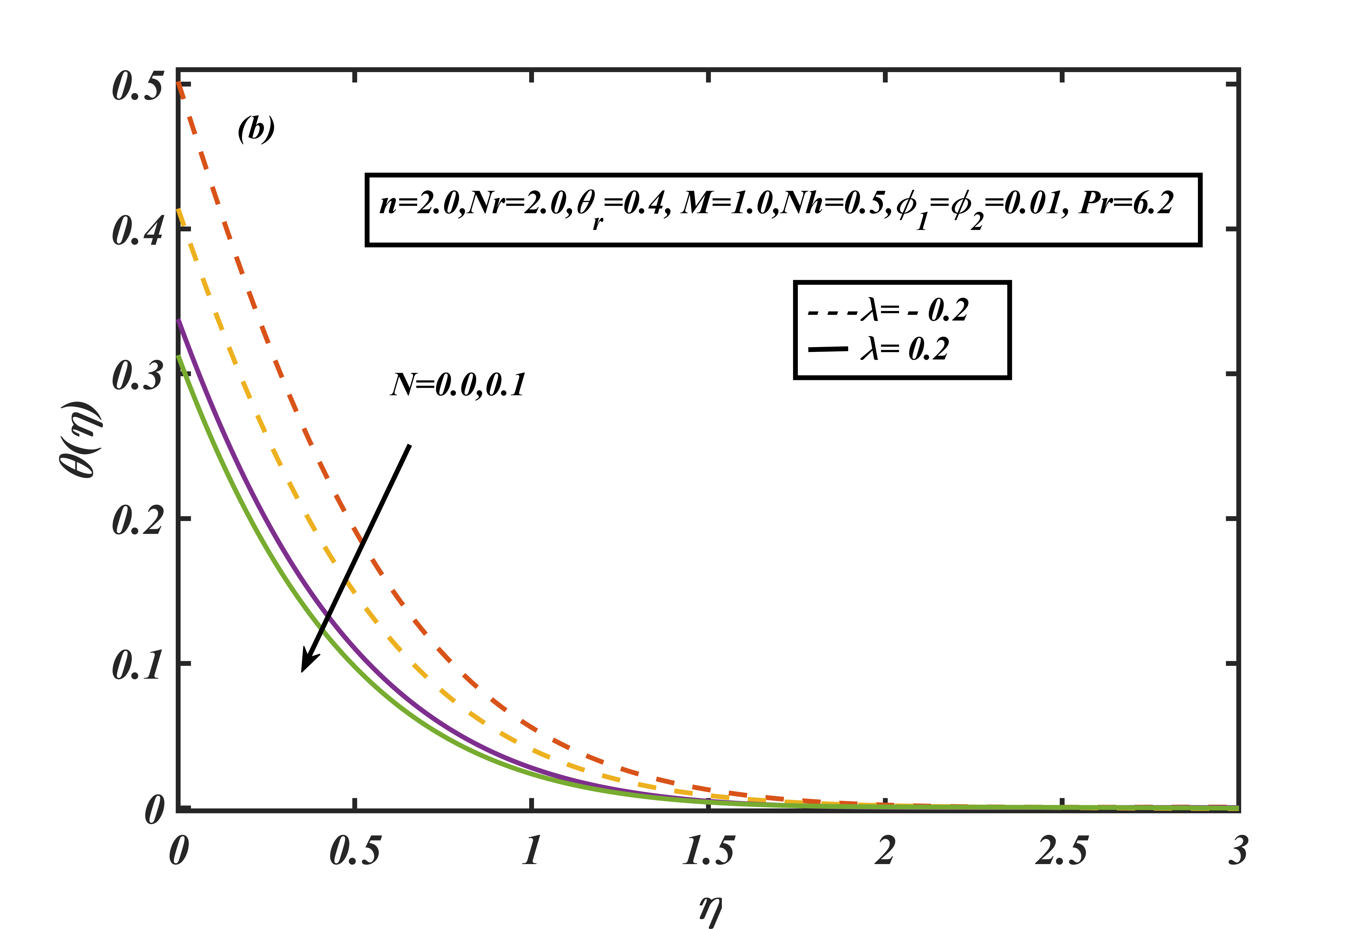

Figure 10: Effect of $N$ on (a) velocity profiles and (b) temperature profiles via $λ$

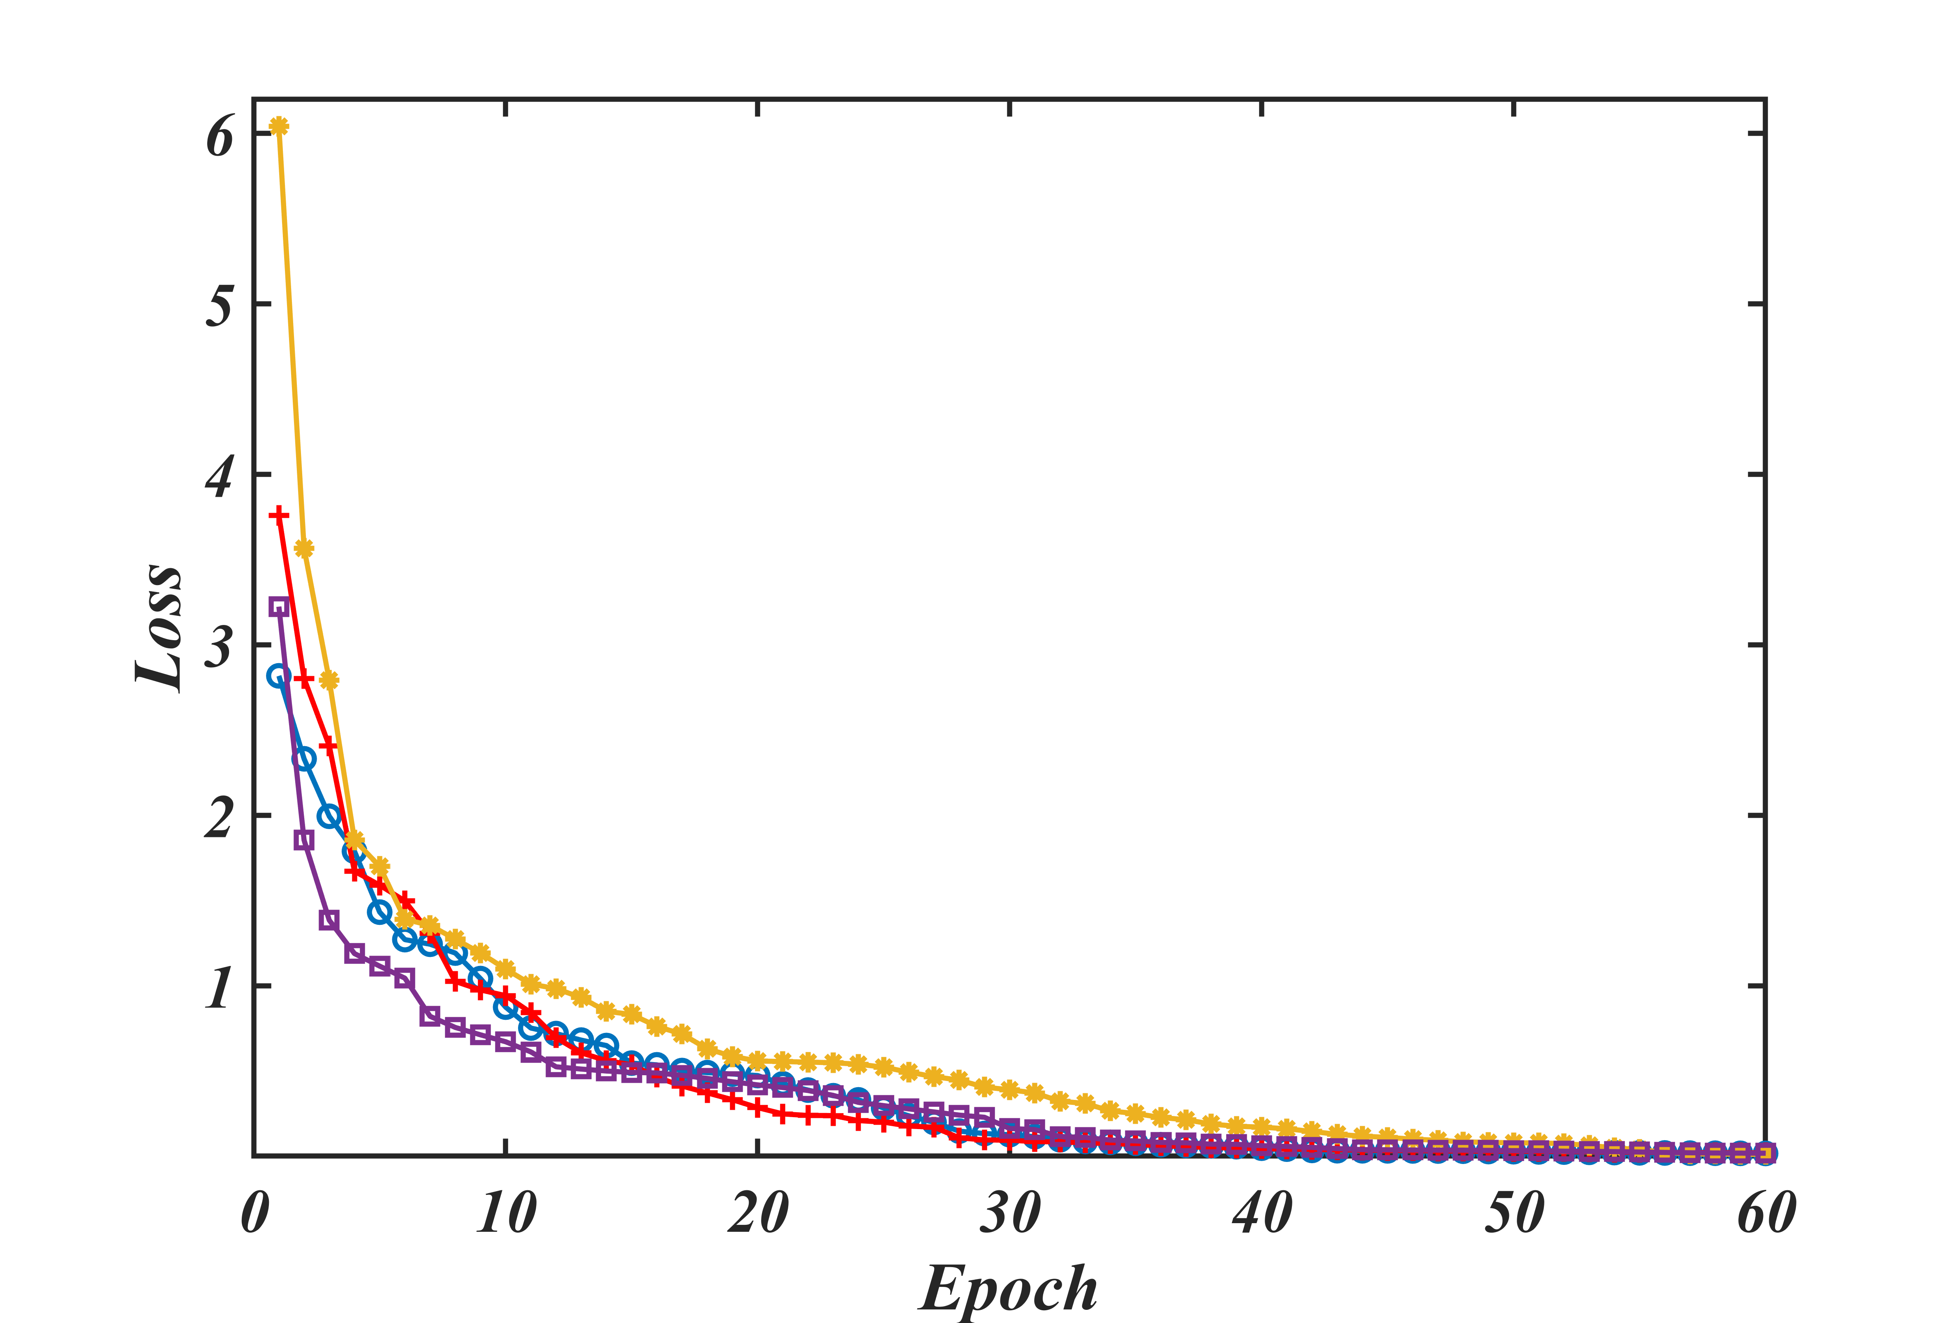

Figure 11: PINN training loss with the iteration.

In Fig.10 (a, b) we consider shrinking $(λ=-0.2)$ and stretching $(λ=0.2)$ with slip flow $(N=0.1)$ and no slip flow $(N=0)$ on velocity profile and thermal profile. When we consider $λ=-0.2$, N show positive effect on velocity profile, as we consider $N=0.1$, this value initially gives the extra acceleration $(f^{'}\left(0\right)=λ+Nf''(0)$) on velocity profile as a result velocity profile increase, this increasing velocity help to carry out heat from the lower plate to the surrounding fluids thus temperature profiles are showing negative effect with increasing $N.$ Stretching sheet with slip flow shows higher velocity profile than the stretching sheet with no slip, in this scenario thermal profiles also decrease.

In Fig. 11, PINN model loss function plotted, here we can also see that loss function decreasing with the number of epoch so solutions convergence for 4 cases. The estimated loss value for each case is: $1.46E-05, 3.39E-05, 3.73E-05 and 1.64E-05.$

In Fig. 12 (a) we consider the behavior of Newtonian heating effect $(Nh)$ on thermal profiles $θ(η)$. Clearly $θ(η)$  and its associated thermal boundary layer thickness enhances. [Heat transfer coefficient](https://www.sciencedirect.com/topics/chemical-engineering/heat-transfer-coefficient) increases for larger $Nh$ . Therefore, more heat transfers from the heated stretching surface to the cooled surface of the fluid and as a whole temperature of the fluid increases which transfers more heat from the stretching to the fluid. It is noticed that $Nh=0$  relates to insulated wall while $Nh→∞$   represents the [constant wall temperature](https://www.sciencedirect.com/topics/engineering/constant-wall-temperature). Subsequently $Nh$  can be utilized as a cooling operator as a part of the progressed innovative procedure. In Fig. 12(b), effect of $Nr$ is plotted with $η.$ Non-linear radiation increases heat transfer rates near the sheet this results in steeper temperature gradient at the wall leading to larger surface flux so thermal boundary layer decays more rapidly with $η.$

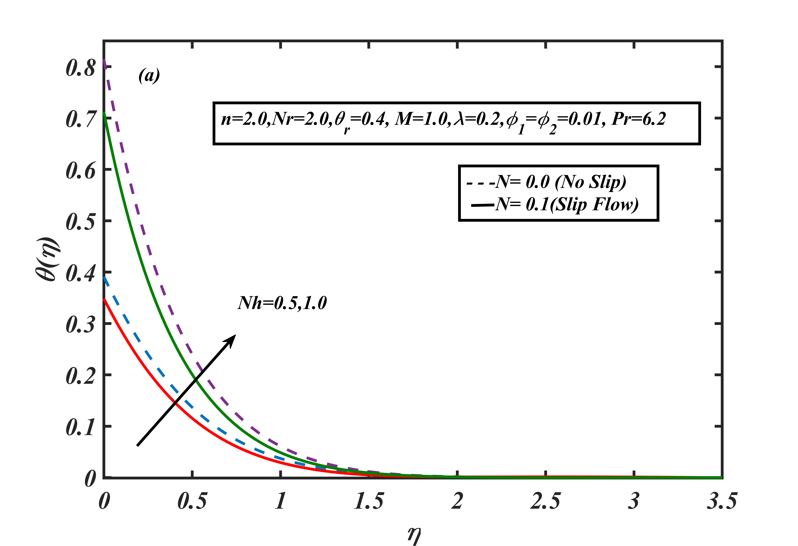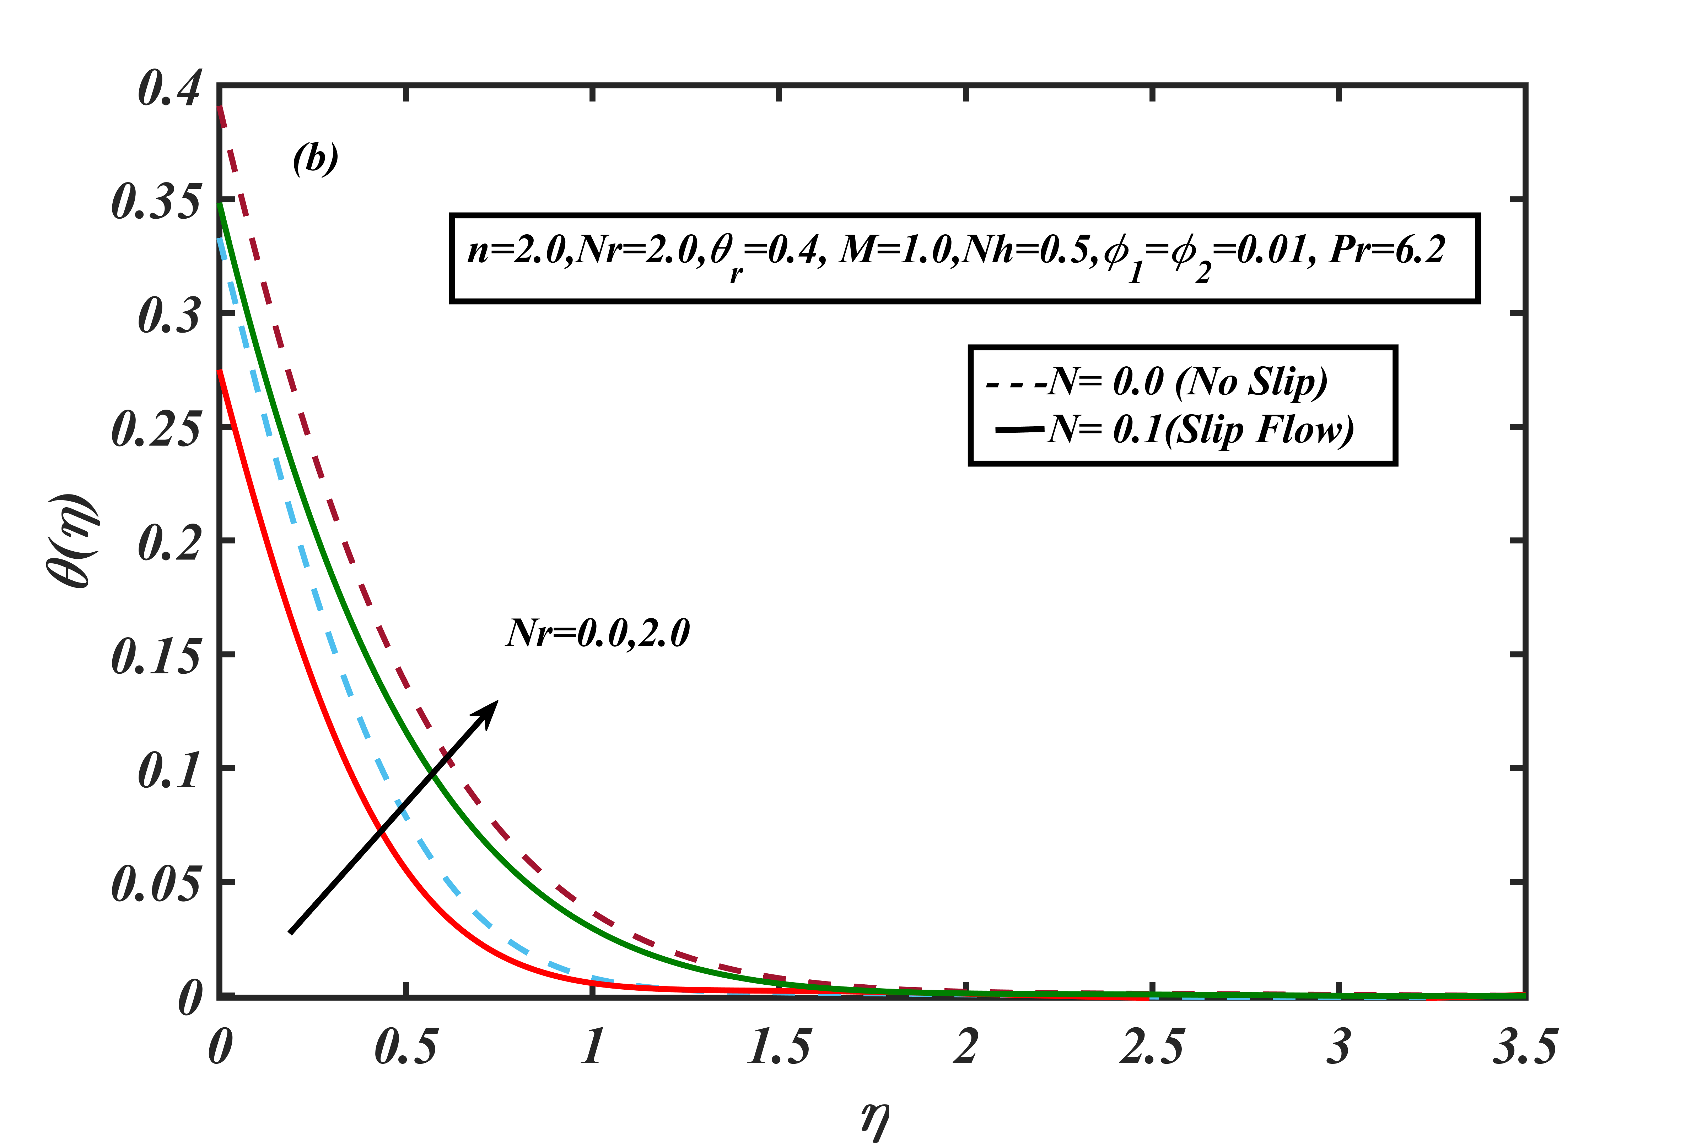

Figure 12: Effect of (a) $Nh$ and (b) Nr on temperature profiles via $N$

In Fig.13 we plotted PINN estimated loss for $Nh \& Nr.$ The final loss of $Nh$ for each case is: $1.86E-05,6.27E-06,5.33E-05 and 1.60E-05$. And the final loss of $Nr$ for each case is: $1.84E-05,1.75E-05,1.97E-05 and 1.53E-05$.

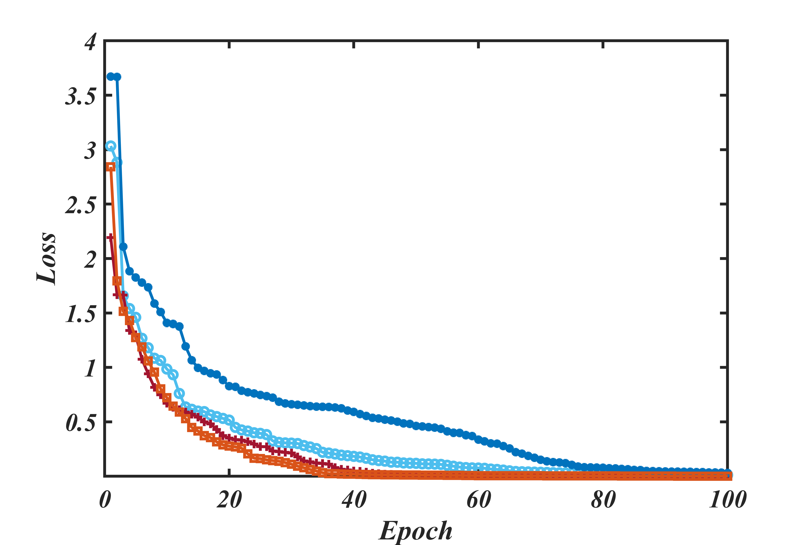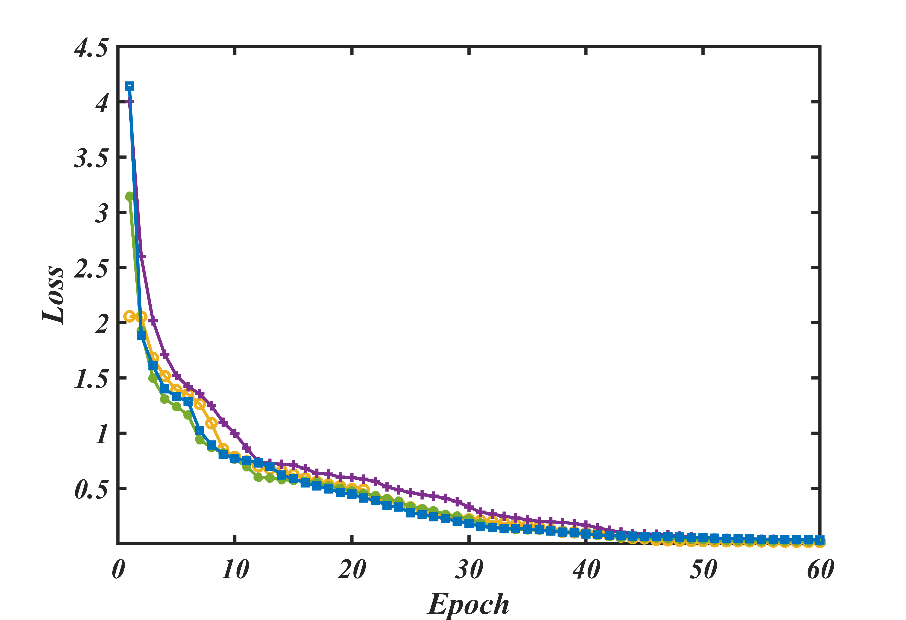

Figure 13: PINN training loss for (a) Nh and (b) Nr with the Epoch.

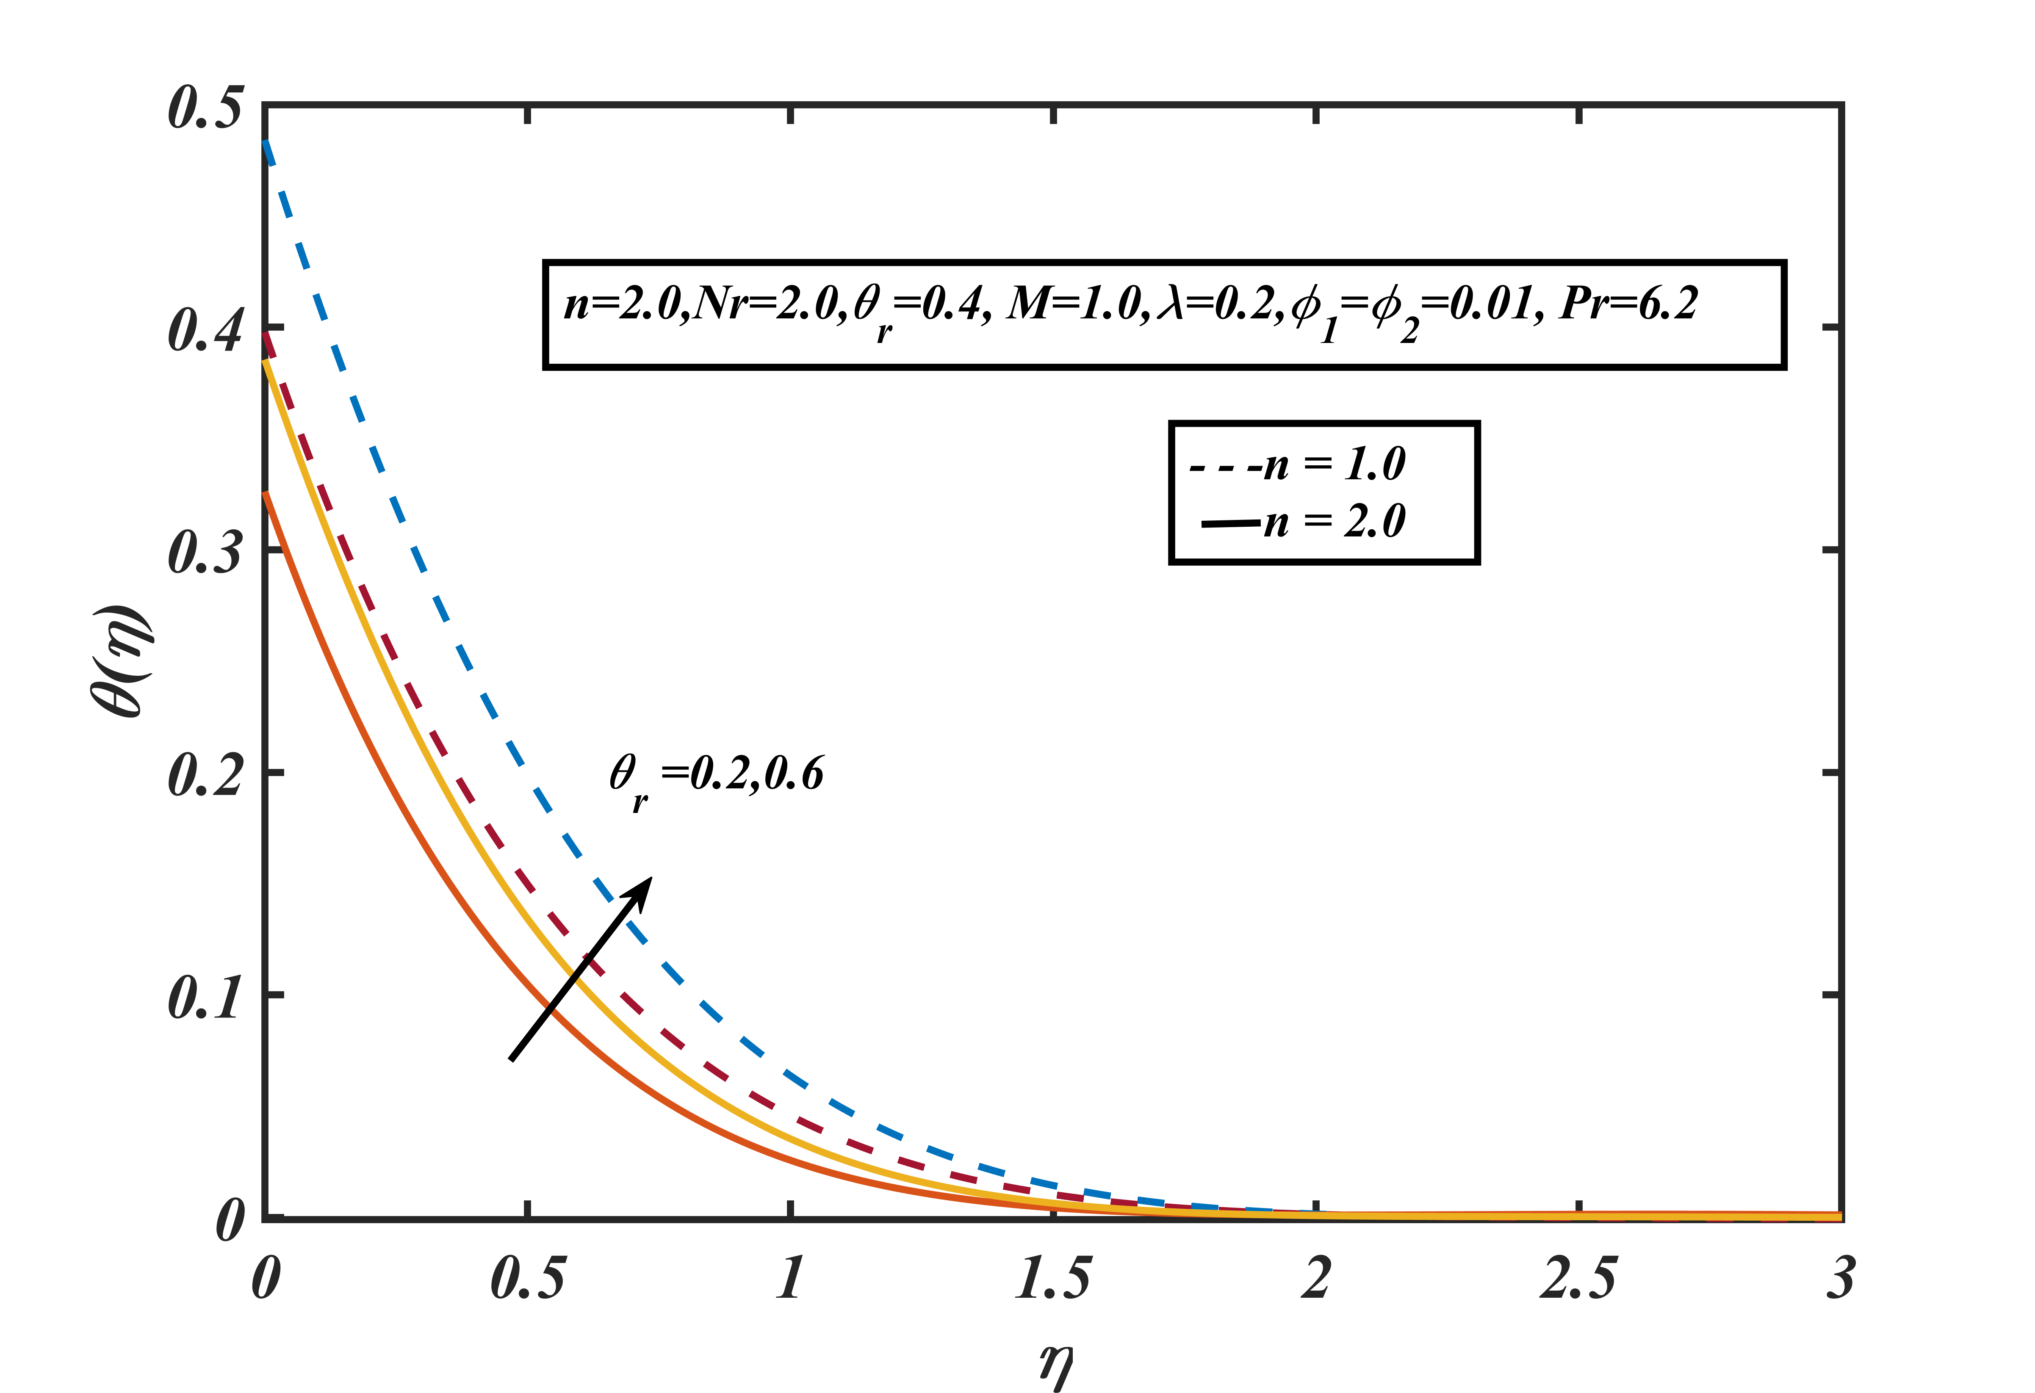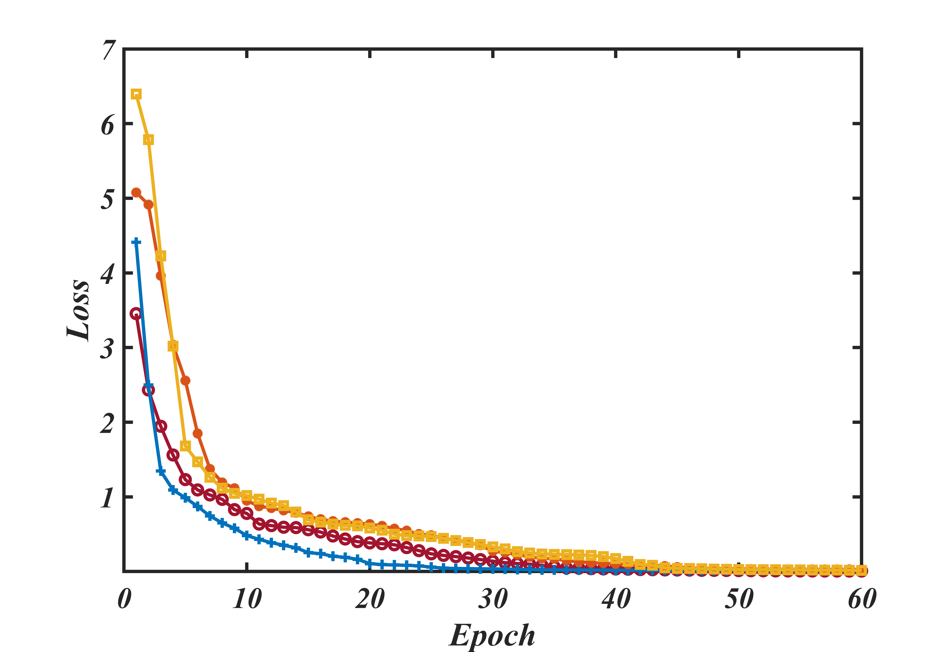

Figure 14: Temperature profiles for $θ_{r}$ with $n.$ Figure 15: PINN training loss.

From Fig. 14, we can observe that temperature profile is decreasing with $η$ but while increasing $θ_{r}$ thermal profile boasts up and from Fig. 15 PINN training loss is decreasing with the epoch that ensures solution validity. The final loss for each case is: $1.4327E-06,2.5845E-05,3.0815E-05 and 5.8392E-06$.

1. **Conclusions**

Physics-based neural networks were utilized to calculate MHD stagnation flow in media in the presence of radiation factors. This technique's basic concept was that the networks were trained using loss functions with respect to the governing equations and the boundary conditions. The following are the outcomes:

* Velocity increases for increasing magnetic number $M$ but opposite scenario can be observed in thermal profile that is thermal profile is decreasing with $M$.
* Thermal profile increases for increasing as radiation heating becomes more dominant because increasing radiation effect results in higher heat transfer rate from the lower surface to the surrounding fluids as a result thermal profile increase. Similar phenomena can be observed for conjugating parameters for Newtonian heating.
* The velocity slip parameter provides extra acceleration in the initial state, so velocity profile gets higher value near boundary layer.
* Velocity profile increases for increasing $n$ but opposite scenario can be observed in thermal profile that is thermal profile is decreasing with $n$.
* In the PINN methodology, at every boundary location, it minimizes the loss function by satisfying the governing equation as well as the boundary conditions, so this method takes more time than the numerical computation, but it gives better results at that training boundary location. It can also predict the flow profile in between training nodes throughout the boundary region, according to its superb learning.
* Numerical findings were compared with the estimated solutions predicted by PINN. It turned out that the predictions and the results of the numerical approach agreed reasonably well.
* In comparison with the ANN methodology, which required a guess solution, in the PINN methodology, guess solutions are not required. And the ANN toolbox, which requires numerical data first to train the model, can predict the results according to learning, but PINN doesn’t need numerical solutions for its training. So, it's an alternative tool to solve the boundary layer equation as well as the nonlinear equation using this intelligent technique. So, we can conclude that the that the PINN technique for solving boundary layer equations is more reliable and easier to handle.

**Future direction:**

One can easily extend the study for trihybrid bio-nano fluid flow over catalytic/radiative surface. Entropy generation can be done for this study to maintain minimum energy loss.

**Acknowledgements:**

This work has been carried out in AIUB. The authors thanks AIUB authority for financial support.

**Conflicts of Interest**

The authors declare no conflict of interest.

**References**

[1] Zhao H.C, Wang Y.Q. Friction performance analysis of lubricated coated gear with magnetic fluid in CNC machine tools. Manufacturing Technology and Machine Tools, 12:127-31,2021.

[2] Sun et al. Magnetic lubricants: preparation, physical mechanism, and application. Friction, 2024.

[3] Wang Z.L. Research on magnetic fluid lubrication and sealing of rolling bearings. Tribology, 25, 88-91, 2005.

[4] Yong H, Nee Z.I, Jiann L.Y., and Yahaya S.D, Aqueous Humour Flow in Descemet’s Membrane Detachment With Different Orientation and Temperature Gradient. Journal of Advanced Research in Fluid Mechanics and Thermal Sciences 127 (2):77-92, 2025.

[5] Wang CY., Stagnation flow towards a shrinking sheet, Int J Nonlinear Mech., 43(377–82), 2008.

[6] Anuar I., Khamisah J., Roslinda N., Ioan P., MHD stagnation point flow towards a stretching sheet, Physica A: Statistical Mechanics and its Applications, 388(17), 3377-3383, 2009.

[7] Ali F.M., Nazar R., Arifin N.M. *et al.,* MHD stagnation-point flow and heat transfer towards stretching sheet with induced magnetic field, *Appl. Math. Mech.-Engl. Ed.,* 32, 409–418, 2011.

[8] Hayat T., Javed T., Abbas, Z., MHD flow of a micropolar fluid near a stagnation-point towards a non-linear stretching surface, Nonlinear Analysis: Real World Applications, 10(3), pp.1514-1526, 2009.

[9] Daniel, Yahaya Shagaiya, Zainal A.A, Zuhaila I, Arifah B, and Faisal S., Stratified electromagnetohydrodynamic flow of nanofluid supporting convective role,  *Korean Journal of Chemical Engineering* 36, 1021-1032, 2019.

[10] Zeyu L., Rong F, Yan Y., Chapter 2 - Preparation and evaluation of stable nanofluids for heat transfer application, Editor(s): Hafiz Muhammad Ali, Advances in Nanofluid Heat Transfer, Elsevier, pp. 25-57, ISBN. 9780323886567, 2022.

[11] Bharat A.B., Divya P.B., Shirish H.S., Nishant K., Shriram S., Chapter 40 - Intensified Heat Transfer Rate with the Use of Nanofluids, Editor(s): Chaudhary Mustansar Hussain, In Micro and Nano Technologies, Handbook of Nanomaterials for Industrial Applications, Elsevier, pp. 739-750, ISBN. 9780128133514, 2018.

[12] Ali A.R.I., Salam B., A review on nanofluid: preparation, stability, thermophysical properties, heat transfer characteristics and application, *SN Appl. Sci.* 2(1636), 2020.

[13] Makinde O.D., Khan W.A. and Khan, Z.H., Buoyancy effects on MHD stagnation point flow and heat transfer of a nanofluid past a convectively heated stretching/shrinking sheet, *International journal of heat and mass transfer*, *62*, 526-533, 2013.

[14] Buongiorno J. Convective transport in nanofluids. *J. Heat Transfer*. Mar 2006, 128(3): 240-250.

[15] Choi S.U, Eastman J.A. Enhancing thermal conductivity of fluids with nanoparticles. Argonne National Lab.(ANL), Argonne, IL (United States); 1995.

[16] Ramzan M, Gul H, Chung JD, Kadry S, Chu Y.M. Significance of Hall effect and Ion slip in a three-dimensional bioconvective Tangent hyperbolic nanofluid flow subject to Arrhenius activation energy. Scientific Reports. 10,18342, 2010.

[17] Turkyilmazoglu M. Single phase nanofluids in fluid mechanics and their hydrodynamic linear stability analysis. Computer Methods and Programs in Biomedicine. 187, 105171, 2020.

[18] Katta R, Jayavel P. Heat transfer enhancement in radiative peristaltic propulsion of nanofluid in the presence of induced magnetic field. Numerical Heat Transfer, Part A: Applications. 79, 83-110, 2020.

[19] Daniel, Y.S., Ismail, Z., Ayuba, P. et al., Radiative heat transfer and Ohmic heating on unsteady EMHD mixed convective flow for dual stratified nanofluid, Model. Earth Syst. Environ. 11, 190, 2025.

[20] Khan M.I, Waqas M, Hayat T, Alsaedi A. A comparative study of Casson fluid with homogeneous-heterogeneous reactions. Journal of colloid and interface science, 498:85-90,2017.

[21] Li F, Sheikholeslami M, Dara RN, Jafaryar M, Shafee A, Nguyen-Thoi T, et al. Numerical study for nanofluid behavior inside a storage finned enclosure involving melting process. Journal of Molecular Liquids.; 297,111939, 2020.

[22] Thirunanasambantham K., Zuhaila I., Lim Y.J., Amnani Shamjuddin, and Yahaya Shagaiya Daniel. "Investigation of Mass Transfer in Generalized Power Law Blood Flow through Multiple Stenosed Artery." *International Communication in Computational Mechanics* 1(1), 52-74, 2025.

[23] Merkin, J.H. Natural-convection boundary-layer flow on a vertical surface with Newtonian heating,  International Journal of Heat and Fluid Flow, 15, no. 5, 392-398,1994.

[24] Salleh M.Z, Roslinda N. and Pop. I., Boundary layer flow and heat transfer over a stretching sheet with Newtonian heating." Journal of the Taiwan Institute of Chemical Engineers 41, no. 6, 651-655, 2010.

[25] M. Raissi, P. Perdikaris, G.E. Karniadakis. Physics-informed neural networks: A deep learning framework for solving forward and inverse problems involving nonlinear partial differential equations, Journal of Computational Physics, 378, 686-707,2019.

[26] Sana M., Farooq, M.U., Saqib A., and Rodolfo H., Predictive modelling framework on the basis of artificial neural network: A case of nano-powder mixed electric discharge machining. *Heliyon* 9, no. 12, 2023.

[27] Cuomo, S., Di Cola, V.S., Giampaolo, F. *et al.* Scientific Machine Learning Through Physics–Informed Neural Networks: Where we are and What’s Next. *J Sci Comput,* 92, 88 2022.

[28] Wu Y.C., Feng J.W., Development and application of artificial neural networks, *Wireless Personal Communications*, *102*, 1645-1656, 2018.

[29] Abiodun O. I., Jantan A., Omolara A. E., Dada K. V., Mohamed N. A., Arshad H., State-of-the-art in artificial neural network applications: A survey, *Heliyon*, *4*(11), 2018.

[30] Abdi H., A neural network primer. *Journal of Biological Systems*, *2*(03), 247-281, 1994.

[31] Dongare A.D., Kharde R.R., Kachare A.D., Introduction to artificial neural network. *International Journal of Engineering and Innovative Technology (IJEIT)*, *2*(1), 189-194, 2012.

[31] Albawi S., Mohammed T.A., Al-Zawi S, Understanding of a convolutional neural network. In *2017 international conference on engineering and technology (ICET),* IEEE, 1-6, 2017.

[33] Bishop C.M., Neural networks and their applications. *Review of Scientific Instruments*, *65*(6), 1803-1832, 1994.

[34] Milano M., Koumoutsakos P., Neural network modeling for turbulent flow near wall. *Journal of Computational Physics*, *182*(1), 1-26, 2002.

[35] Ling J., Kurzawski A., Templeton J, Reynolds averaged turbulence modelling using deep neural networks with embedded invariance, J. Fluid Mech. 807, 155–166, 2016.

[36] Sarghini F, Felice G.D, Santini S., Neural networks based subgrid scale modeling in large eddy simulations, Comput. Fluids 32 (1), 97–108, 2003.

[37] Srinivasan P.A, Guastoni L, Azizpour S., Vinuesa P.R, Predictions of turbulent shear flows using deep neural networks, Phys. Rev. Fluids 4 (5), 054603, 2019.

[38] Teo C.L, Lim K.B., Hong G.S., Yeo M.H.T., A neural net approach in analyzing photograph in PIV, in: Proceeding IEEE International Conference on Systems, Man and Cybernetics, Charlottesville, VA, USA, 3, 1535–1538, 1991.

[39] Colvert B, Alsalman M, Kanso E, Classifying vortex wakes using neural networks, Bioins. Biomimet. 13 (2), 025003, 2018.

[40] Dissanayake M, Phan-Thien N, Neural-network-based approximations for solving partial differential equations, Commun. Numer. Methods Eng. 10 (3), 195–201, 1994.

[41] Lagaris I.E., Likas A, Fotiadis DI, Artificial neural networks for solving ordinary and partial differential equations, IEEE Trans. Neural Netw., 9 (5), 987–1000, 1998.

[42] Raissi M, Perdikaris P, Karniadakis GE, Physics-informed neural networks: a deep learning framework for solving forward and inverse problems involving nonlinear partial differential equations, J. Comput. Phys. 378, 686–707, 2019.

[43] Mutuk H, A neural network study of Blasius equation, Neural. Process. Lett., 51, pp. 2179–2194, 2020.

[44] Bararnia H., Esmaeilpour M., On the application of physics informed neural networks (PINN) to solve boundary layer thermal-fluid problems. *International Communications in Heat and Mass Transfer*, *132*, 105890, 2022.

[45] Akbar N.S, Tayyab Z., Tayyaba N., Taseer M., and Mohamed R.A., Heat transfer enhancement using ternary hybrid nanofluid for cross-viscosity model with intelligent Levenberg-Marquardt neural networks approach incorporating entropy generation, *Case Studies in Thermal Engineering* 63, 105290, 2024.

[46] Akbar N.S, Tayyab Z., Javaria A., Tayyaba N., and Taseer M., Simulation of hybrid boiling nano fluid flow with convective boundary conditions through a porous stretching sheet through Levenberg Marquardt artificial neural networks approach, *International Journal of Heat and Mass Transfer* 228, 125615, 2024.

[47] Sher A.N., Tayyab Z., Bilal S, and Taseer M., Computational study with neural networks to double diffusion in Prandtl thermal nanofluid flow adjacent to a stretching surface design with numerical treatment." *Proceedings of the Institution of Mechanical Engineers, Part N: Journal of Nanomaterials, Nanoengineering and Nanosystems* 23977914241289978, 2024.

[48] Alghamdi M., Noreen S.A, Tayyab Z., and Taseer M., Double layered combined convective heated flow of Eyring-Powell fluid across an elevated stretched cylinder using intelligent computing approach, *Case Studies in Thermal Engineering* 54, 104009, 2024.

[49] Shah F.A., Tayyab Z., Noreen S.A., and Alexay M., Levenberg-marquardt design for analysis of maxwell fluid flow on ternary hybrid nanoparticles passing over a riga plate under convective boundary conditions, *Results in Engineering* 24, 103502,2024.

[50] Mabood F., Khan, W.A., and Ismail A.I.M, MHD boundary layer flow and heat transfer of nanofluids over a nonlinear stretching sheet: a numerical study, Journal *of Magnetism and Magnetic Materials* 374, 569-576, 2015.

[51] Uddin, M.J, Bég, O.A and Uddin, M.N, Energy conversion under conjugate conduction, magneto-convection, diffusion and nonlinear radiation over a non-linearly stretching sheet with slip and multiple convective boundary conditions." *Energy* 115, 1119-1129,2016.

[52] Rashid M., Khan M.I, Hayat T., Khan M.I., and Alsaedi A., Entropy generation in flow of ferromagnetic liquid with nonlinear radiation and slip condition, *Journal of Molecular Liquids* 276, 441-452,2019.

[53] Mahatha B.K., Nandkeolyar R., Nagaraju G., and Das M, MHD stagnation point flow of a nanofluid with velocity slip, non-linear radiation and Newtonian heating, Procedia *Engineering* 127, 1010-1017, 2015.

[54] Daniel Y.S, Zainal A.A., Zuhaila I., Arifah B., and Faisal S., Slip role for unsteady MHD mixed convection of nanofluid over stretching sheet with thermal radiation and electric field, *Indian Journal of Physics* 94, 195-207, 2020.

[55] Daniel Y.S., and Simon K.D., Effects of buoyancy and thermal radiation on MHD flow over a stretching porous sheet using homotopy analysis method." *Alexandria Engineering Journal* 54, no. 3, 705-712,2015.

[56] Daniel Y.S., Zainal A.A., Zuhaila I., and Faisal S., Numerical study of entropy analysis for electrical unsteady natural magnetohydrodynamic flow of nanofluid and heat transfer." *Chinese Journal of Physics* 55, no. 5, 1821-1848,2017.

[57] Imran M.M.H., Muhammad S.H, Billah M.M, and Humaira F., On the applications of Neural Network technique for Electro-viscoplastic Casson hybrid Ferrofluid with a Permeable Channel, *International Journal of Thermofluids* 100976, 2004.

[58] Seshadri, R., Na, T.Y., Group Invariance in Engineering Boundary Value Problems. Springer (1985)

[59] Vajravelu, K., Viscous flow over a nonlinearly stretching sheet, *Applied Mathematics and Computation* 124, no. 3, 281-288, 2001.

[60] Aladdin N.A.L, Norfifah B., and Pop I, Cu-Al2O3/water hybrid nanofluid flow over a permeable moving surface in presence of hydromagnetic and suction effects, Alexandria *Engineering Journal* 59, no. 2, 657-666, 2020.

[61] Daniel Y.S, Zainal A.A., Zuhaila I., and Faisal S., Slip Effects on Electrical Unsteady MHD Natural Convection Flow of Nanofluid over a Permeable Shrinking Sheet with Thermal Radiation, Engineering *Letters* 26, no. 1, 2018.